CatSim v4 User Manual

UOP LLC
Date of Last Modification: 12/10/2003
CONTENTS

1 INTRODUCTION 4
1.1 Background and basic Description 4
1.2 What’s New in v4 5
1.3 Installation and Licensing of Catsim v4 6
2 CATSIM: GETTING STARTED 11
2.1 Catsim Software 11
2.2 Quick Start: Opening the Model, Calibrating and Making Predictions 11
3 TECHNICAL BASIS AND STRUCTURE 13
3.1 Operational Modes 13
3.2 Heat Balance Module 14
3.3 Reactor Yield and Product Quality Modules 15
3.4 TLP prediction and Fractionation Module 17
3.5 Feed Characterisation 18
3.6 Design Parameters 19
3.7 Recycle 20
3.8 Catalyst Management 21
3.9 Gasoline PIANO Representation 22
3.10 Wet gas calculations 23
3.11 Iterative calculation loops in Catsim 23
4 FINDING YOUR WAY AROUND THE CATSIM SPREADSHEET 24
4.1 Fixed format and User format 24
4.2 Unit Monitoring sheet 24
4.3 CatSim sheet 27
4.4 Gasoline Composition sheet 29
4.5 Property Distributions sheet 31
4.6 Feed Blender sheet 31
4.7 Step Out sheet 32
4.8 Forward Predict sheet 33
5 HOW TO USE CATSIM/ CALCULATION OPTIONS 34
5.1 Processing Unit Test-run Data 34
5.2 Calibrating CatSim 35
5.3 Carrying out a Prediction 36
5.4 Using the Feed Blender 39
6 TROUBLESHOOTING 41
6.1 Error Messages and Warnings 41
6.2 Problems When Opening the Spreadsheet 41
6.3 Predict is not Equal toBase 42
6.4 Metals/Activity InputIissues 42
6.5 Excel Crashing. 43
APPENDIX A MORE TECHNICAL ISSUES IN CATSIM 44
A.1 Calculation Flow Diagrams 45
A.2 Heat Balance 47
A.3 Prediction of Standard Yields 48
A.4 Fractionation and Prediction of Plant Yields 51
A.5 Product Quality Prediction 54
A.6 Product Recycle Prediction 56
A.7 Catalyst Management Calculations 58
A.8 Material Balance and Element Balances 61
A.9 Distillation Conversion Methods 62
A.10 Physical Property Calculations and Conversions 68
APPENDIX B MODEL RESPONSE TO KEY PARAMETER CHANGING 70
B.1 Charts of Step Changes 70

1 INTRODUCTION

1.1 Background and Basic Description

CatSim calculates outputs y (steady-state yields, product properties and dependent operating conditions) based on an input set x of feed properties, catalyst properties and independent FCC operating variables. The model predicts standard yields of C₅ and lighter components, C₅-221°C gasoline, 221-350°C LCO, 350°C DCO, and coke. In addition to these standard cut liquid product predictions, the model, when running in “plant yields” mode, can predict the yields and qualities of up to three gas and seven liquid product streams at any cut-point specified by the user.

In general, the model technology can be described as a relationship between inputs x, outputs y and a set of adjustable parameters θ
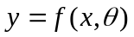

Examples of adjustable parameters used in the model are coefficients in empirical correlations, corrections to pseudo-kinetic constants, fractionation indices and unit factors.

The model operates in two separate modes, Calibrate and Predict. In the first mode, CatSim is “calibrated” on a chosen set of data (x,y), defining the base case. The result of the calibration is a set of adjustable parameters θ based on this data and the above relationship. These parameters are typically used to “tune” the model to the operation of a specific unit. The predict mode typically uses the set of unit factors generated in the base case to predict, according to the above relationship, new yields and properties as a response to changes to a range of independent variables specified by the user or a general purpose optimiser.

CatSim can be used in a wide range of applications which include process monitoring, daily unit optimisation, longer term optimisation (e.g. feed selection, catalyst reformulation), de-bottlenecking studies, evaluating the effect of changing design parameters, unit revamps, the generation of FCC LP representations.

This manual is meant to assist the novice user in getting started using the model. For further information on the CatSim model, its use, and application please contact your UOP LLC service representative.

1.2 What’s New in v4

For users familiar with previous Catsim versions, major technology changes in this version are highlighted below:

- Gasoline PIANO composition for plant streams.
- Heat balance includes lift gas and riser water.
- Sulfur: new S in coke equation, improved sulfur curve.
- More robust heat balance calculations.
- A number of bugs fixed.

In the Excel interface, the new feature introduced by version 3 are kept such as the ability of the spreadsheet to interact with a separate catalyst selection tool developed to facilitate pilot-plant data driven catalyst evaluation. Contact your UOP support engineer for more information on this tool.

The major modification of the interface for v4 from V3.11 is the gasoline composition page. New layout and formulas are implemented for the page of “Gasoline Composition”.

Another new item introduced with version 4 is this updated user manual which will be part of the installation, so the user can easily access into the manual for reference.

Due to different/expanded input/output, an Excel interface being used for Catsim v3.11 or earlier versions will have to be updated to be able to run with v4. Contact UOP if you need this to be done. There are no major changes to the operation of the model, so that a v3 user should be able to use v4 without major additional training, once familiar with the changes outlined above.

1.3 Installation and Licensing of Catsim V4.0

    - Important Notes

If you are a new user, before you do anything, please contact UOP by email for the authorization. To do so, please provide:
Name
Company
Location
Email
Telephone
What version of Catsim planed to use
We will then add your name to the authorized list.

If you are currently the user of Catsim 3.0 or later version, you do not need to get authorization again. Your license to Catsim 3.0 or later versions will work with Catsim v4.0. All you need to do is installing the v4.0 xlls and upgrading your excel interfaces. UOP only provides the US generic excel interface. For any customized interface upgrading, please contact UOP for information.

There is a software incompatibility between an old version of the API Databook and the UOP process models. There is a new version of the API Databook that does not share this conflict. If you have a version of the API Databook that was installed by BP IT before 11/2001,

You must take the following measures BEFORE installing the CatSim model.

a) Remove the API Databook application using the "Add/Remove Programs" function of the Control Panel

b) Reboot the computer

c) Request an installation of the latest API Databook from the Help Desk (optional)

1.3.2 Installation

The installation will be scripted so that Catsim can be requested through the BP help desk.

The installation files are available on the UOP/BP shared server, under

Alliance File Cabinet/Process Technologies/Fluid Catalytic Cracking/Process Models/Catsim v4.0/installation

To install Catsim manually:

Please double-click on the 3 following files and accept the default install options

- Crypkey NT driver.msi (will install Crypkey, the security software)

- UOP License Manager.msi (will install the License manager)

- Catsim_4.x.x.msi (will install the Catsim files)

Each of the installers might ask you if you want to modify or remove previous installations. This happens if you had previous or beta Catsimv4.0 versions. We suggest removing previous installations. When done, re-click the appropriate file to install the application.

1.3.3 Use the License Manager to Check/Request Authorization.

Select
Start….Programs….UOP Process Models…..FCC….Catsim …UOP license manager

You should see the following dialog

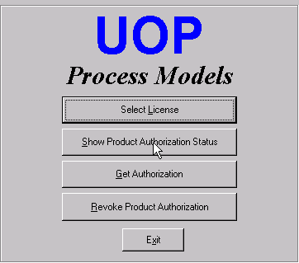

Figure 1.3.3_1

To check authorisation status, select “Show Product Authorization Status” as shown in the above picture. If you are authorised, you should see the “FCC” entry in the following screen

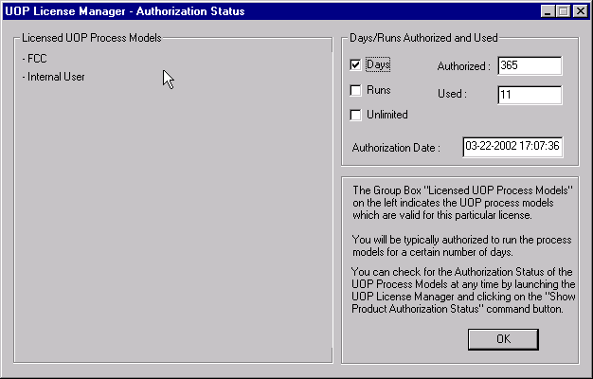
Figure 1.3.3_2

If you are not authorized, request authorization by clicking the “Get Authorization” button in the “UOP Process models” screen. You will see a screen like this

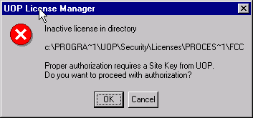
Figure 1.3.3_3

Click the OK button. You will see the following dialog box

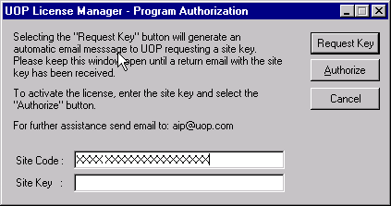
Figure 1.3.3_4

Select the Request Key button. This will send an e-mail to UOP requesting authorization. If you are preauthorized (i.e. you sent your info as contained in the attached CatSim_authorization_template.xls and you have been approved) the system will answer automatically and within one minute from receipt will e-mail an authorization code (site key). Please keep the above window open, and, when you receive e-mail authorization from UOP copy the site key from the e-mail to the Site Key space in the above dialog box and click the Authorize button.
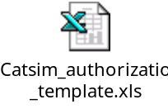1.3.4 Start Using the Model,

Select
Start….Programs….UOP Process Models…..FCC….Catsimv4.0 …US generic Catsim v4

This is a read-only generic interface (US units) which you should save wherever is convenient. As in previous Catsim versions, the spreadsheets can be stored in any directory. Depending on security settings, you might need to click the Enable Macro button in a dialog box.

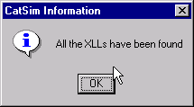
You should then see two dialog boxes

Figure 1.3.4_1
And

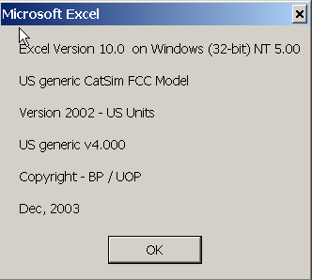

Figure 1.3.4_2

After clicking OK on these dialog boxes, the model should be working.

In some cases, the user may see an error message in the Excel macro right after clicking “Enable Macro” button. This is usually due to the problem of “missing Solver.xla” in the reference of Excel macro. The user should re-set the reference of Solver.xla in the Excel macro editor. The following is the procedure to do this.

- Stop the debug mode in the macro editor.
- Open the Tools menu in macro editor and click the reference command.
- Uncheck the box for “missing solver”.
- Open Browse…
- Locate the file solver.xla. It is usually located in the C:\Program File\Microsoft Office\Office10\Library\Solver. If it is not there, you may need to find its location by using Find file command in the Window Start.
- High Light the solver.xla and click Open.
- Back to Reference list check the Box for Solver and save it.

1.3.5 xldiscon

The Catsim spreadsheet interface uses some utilities for distillation conversion and blending which were part of Catsim v2 and earlier dlls. These used to overlap/conflict with routines available from another tool in wide use (xldiscon) so we removed them from the Catsim xlls. We are distributing the latest version of that tool (xldiscon.xll) which needs to be loaded to use some optional interface features (feed blender, for example). Unlike for the Catsim xlls functions (which are registered through the Catsim spreadsheet AutoOpen macro), we suggest loading the xldiscon.xll through the Tools..Add-in menu. Alternatively, you may just open xldiscon.xll from an Excel file menu. A copy of the xll is located in the standard Catsim installation directory, which by default is C:\program files\uop\process models\fcc\catsim\v4.x

A spreadsheet (xldiscon.xls) which illustrates the use of these functions is also available in the distribution.

2 CATSIM: GETTING STARTED

2.1 Catsim Software

CatSim is coded in C++ and, for Windows applications, compiled in either xlls or dlls, dynamically link libraries. This manual is intended mainly for use with the Excel spreadsheet interface, which calls routines contained in xlls. There are 2 xll files, cs2002c.xll and cs2002p.xll, which contain the routines used for calibrate and predict mode respectively. Corresponding dlls exist for using with non-Excel Catsim application (for example, the Hysys Catsim interface).

Starting with version 3, the model is protected though CrypKey security software hence an authorisation is required. However, once the authorisation is obtained, there is no need of new authorization for the new version of Catsim. This means that if a user has Catsim 3.0 or later versions working on his computer, he does not need a new license for Catsim v4.0. Please see the section 1.3.3 for details.

2.2 Quick Start: Opening the Model, Calibrating and Making Predictions

Once the model is installed and authorisation is obtained, you can start the model by opening the Excel spreadsheet interface. If you do not have a specific one for your refinery/application, a generic read-only spreadsheet can be opened by navigating to

Start…Programs…UOP Process Models…FCC…Catsim v4.0…US_generic_Catsim_v4.xls.

Upon opening the spreadsheet, depending on the security settings, you might see a dialog box asking if you want to enable macro execution. After enabling macros (if needed), a dialogue box will appear to inform the user that “All of the xll’s (dll’s for versions 2 and earlier) have been found”. Click on “OK” and a second dialogue box will appear to give the user information about the model. Clicking on “OK” will allow CatSim to open completely. If any messages appear other than these two, something has gone wrong. Please refer to section 6 for advice on troubleshooting.

The spreadsheet has 2 main tabs: the Unit Monitoring tab and the Catsim tab, used to run the Calibrate and Predict mode respectively.

First you need to calibrate the model. In the Unit monitoring tab, you will typically see a series of test runs (columns). Select one of the runs as base case by selecting any of the cells in that column, and then click the button “Calibrate”. The model is now calibrated on that base case.

Now switch to the Catsim page. In this tab, where you perform model predictions, you will see sections with two columns labelled as base and predict. The base values came from the calibrate case and cannot be changed (their font should be black). The “predict” values to the right of each section are the inputs (red) and outputs (black) for the predict mode. If the base case had consistent and valid information, the model should have been able to Calibrate and re-predict the same output values in Predict mode. See section 6 if that is not the case (i.e. if the output values in the predict area are different from the base values).

You are now ready to make predictions by simply changing one or more of the red values (inputs) and observe the resulting outputs (the black values) in the predict area for each section.

You can navigate the Catsim spreadsheet through the items in the “Catsim” Excel menu. To reset the predict mode inputs to the base case values after making a few changes, you can use the last two entries in the Catsim menu. See section 5 for more info.

3 TECHNICAL BASIS AND STRUCTURE

This section of the manual is designed to give a very brief overview of the technology contained within CatSim. More discussion and some typical results of simulation can be found in appendix A and B of this manual. For more rigorous description of the technical background, user should read the Technical Manual. However, the information contained within the Technical Manual is commercially sensitive and is available only on a need-to-know basis.

3.1 Operational Modes

As mentioned in the introduction, the model has two modes of operation – associated with producing a base case and then a predict case.

The base case calculations are performed using a set of test run data that is representative of the unit; in effect it calibrates CatSim. Various parameters are calculated from this data set which are normally transferred to the predict case unaltered and used in the calculation of the forward or predict case. It is possible to over-write these values if required. Examples of these parameters which are outputs in the calibrate mode and are inputs to the predict case are the following:

- Yield and Product Quality Unit Factors
- Catalyst Management Unit Factor
- Total liquid product (TLP) curve Unit Factors
- Heat of Cracking Unit Factor
- Fractionation Indices (in imperfect fractionation mode only)

Unit factors adjust equations in the model to match the input test run data. Unit factors are either multiplicative or additive:

Unit factor = or actual - predict

Where: actual is the plant data for the parameter being predicted e.g. H2 yield
predicted is the CatSim prediction of that parameter

The predict case calculates all of the product yields, qualities and dependent operating variables as a result of changes in the feed, catalyst and independent operating variables. The base case unit factors are normally applied to tune the predictions to the commercial FCC.

Each of these modes of operation contains equivalent modules, like a heat balance module, a reactor yield module, a fractionation module, a quality predictions module, and a catalyst management module. The equations in each of the modules are the same, but the sequence of the calculation and input/outputs are different for base and predict mode (see Appendix A.1).

3.2 Heat Balance Module

In the base case, the user inputs the flue gas analysis (Orsat) and either the coke make (“Base Regen” calculation option = 1, in row 18 of US_generic ‘Unit Monitoring’ sheet) or the air rate (“Base Regen” calculation option = 0) and the unknown out of the latter two is calculated. A conventional heat balance is carried out around the regenerator in order to calculate the catalyst circulation rate:

combustion_heat =
CO_combustion_heat + CO2_combustion_heat + H2_combustion_heat

coke_heat_content =
reactor_temp * coke_burnt_wt * coke_heat_capacity

air_heat_content =
blower_discharge_temp * (dry_air_rate *
air_heat_capacity + H2O_in_air * H2O_heat_capacity)

total_heat_in =
combustion_heat + coke_heat_content + air_heat_content

fluegas_heat_content =
fluegas_temp * ∑ (fluegas_component * component_heat_capacity)

regen_heat =
total_heat_in - fluegas_heat_content - coke_desorption_heat - regen_heat_loss - cat_cooler_duty

CATALYST_CIRC_RATE =
regen_heat / cat_heat_capacity / (regen_bed_temp - reactor_temp)

The heat carried by hot regenerated catalyst to the riser/reactor is utilized to heat the feed (and steam) and to crack molecules to lighter species. The reactor heat balance goes:
reactor_effluent_heat_out =
reactor_temp * ∑ (cracking_product * product_heat_capacity) + steam_heat_out

reactor_cat_heat_out =
CATALYST_CIRC_RATE * reactor_temp * cat_heat_capacity + coke_heat_content

reactor_heat_out =
reactor_effluent_heat_out + reactor_cat_heat_out + reactor_heat_loss

feed_heat_in =
feed_rate * fn(feed_temp, feed_properties)

reactor_cat_heat_in =
CATALYST_CIRC_RATE * regen_temp * cat_heat_capacity
reactor_heat_in =
feed_heat_in +steam_heat_in +coke_adsorption_heat + reactor_cat_heat_in

reactor_heat =
reactor_heat_out - reactor_heat_in

predicted_heat_cracking = fn(conversion, feed_properties)

heat_cracking_UF (Btu/lb-feed) =
reactor_heat / feed_rate - predicted_heat_cracking

The heat of cracking unit factor is used as the closure variable for the overall heat balance. Hence any errors in the heat balance will be included in that unit factor. If it is too large (say, more than 50 Btu/lb) the base case data should be checked (blower air rate, flue gas analysis, feed preheat).

In the predict case, the heat balance is driven by the prediction of coke yield. The coke yield equation is of the following form:

Coke Yield = additive + catalytic + metals + stripper

- Additive coke is the coke produced from heavy components present in the feed. It is typically measured by feed Conradson carbon analysis.
- Catalytic coke is the coke formed from the catalytic cracking reactions.
- Metals coke results from the presence of metal contaminants (nickel, and vanadium) on the catalyst surface. Antimony passivation of nickel is included in the coke equation.
- Stripper coke results from entrained and adsorbed hydrocarbons that the stripper has failed to remove from the catalyst. Currently there is no stripper coke representation in CatSim.

If the user changes any of the independent variables in the coke yield equation, a new coke yield is calculated. Based on the new coke yield and either the new regenerator air rate or the new flue gas composition, a new flue gas analysis or air rate is calculated. A conventional heat balance is carried out around the regeneration section in order to calculate a new regenerator bed temperature. Using the new predicted heat of cracking along with the heat of cracking unit factor (typically the same as in the base case), the new feed preheat temperature is calculated from a reactor heat balance.

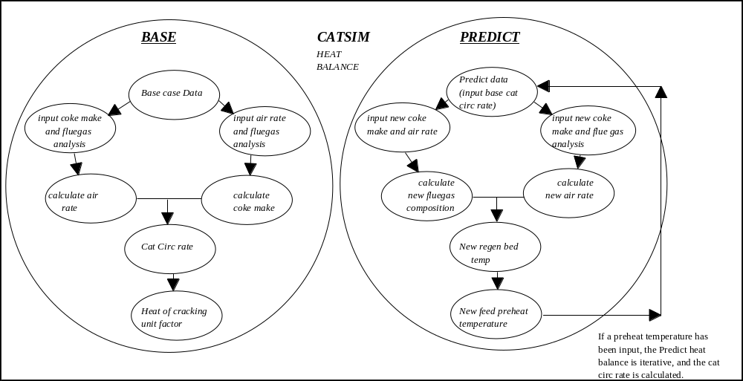

Figure 3.2_1. CatSim Heat Balance Schematic

In the case above, the user inputs the catalyst circulation rate and the feed preheat temperature is calculated. Alternatively, the user can input the feed preheat temperature and calculate the catalyst circulation rate. The former option is a once-through calculation and the latter is an iterative calculation.

CatSim is capable of simulating a single-stage or a two-stage (R2R) regeneration section. However, this manual concentrates on single-stage operation.

The heat balance module accounts for the coke formed in the regenerator due to the combustion of torch oil, as well as the coke on the catalyst. If torch oil is being used, the torch oil rate and properties should be entered into the Unit Monitoring sheet in the regenerator operation data input section.

3.3 Reactor Yield and Product Quality Modules

Most of the key FCC yield and quality equations in CatSim take the form:

Yield = fn{feed, catalyst, operating conditions, design parameters}

The coefficients for the pseudo-kinetic equations were developed largely from FCC circulating pilot plants, and validated with commercial test runs. The pilot plant runs cover a wide range of feed and operating conditions, beyond the scope that would normally be encountered on any one commercial unit. The range of feeds tested includes waxy distillates, thermally-treated and hydrotreated feeds, as well as atmospheric and vacuum residues. The pilot plant based equations can be further tuned to the operation of any commercial FCCU by adjusting the coefficients of the pseudo-kinetic equations.

The base case reactor module generates of a set of unit factors to tune the CatSim yield and quality predictions to the input data. In the predict case, if the user changes any of the independent variables, a new set of yields and qualities are calculated using the CatSim equations, adjusted by the base case unit factors.

CatSim is capable of predicting the following standard yields:

Hydrogen | Propane | [N-Pentane] | C5-221C Gasoline
H2S | Propylene | [I-Pentane] | 221-350C LCO
Methane | N-Butane | [N-Pentene] | 350+C DCO
Ethane | I-Butane | [I-Pentene] | Coke
Ethylene | N-Butene
 | I-Butene
 | Butadiene

The C5 species enclosed in square brackets are typically straight-predicted, i.e. there is no input in the base case and the corresponding unit factors are equal to 1.0.

The yield and product quality modules of CatSim can be run in two modes dependent on the nature of the base case data. If only standard yields are input, then only the standard yields and qualities can be predicted. If however, plant yields are input, both standard and plant yields and plant qualities can be output. The model is capable of predicting the following unit-specific plant yields:

Dry Gas Stream 1,2 or 3 Gasoline Streams
C₃ Product Stream 1 or 2 LCO streams
C₄ Product Stream 1 or 2 DCO streams

For each of these plant streams, the following product qualities can be predicted, provided that the base case contains plant values to calibrate the model:

Gasoline Streams | Heavier Streams
Specific Gravity | Specific Gravity
Sulphur | Sulphur
Distillation | Distillation
RON | Cetane Index
MON | Cloud Point
RVP | Pour Point
PIANO Composition | Viscosity
 | Basic Nitrogen
 | Conradson Carbon

For most liquid streams properties, the quality prediction relies on the prediction of a property distribution curve, i.e. prediction of quality of each narrow fraction, and the prediction of the narrow fraction weight (SIMDIS) of the stream (see Appendix A5.2). The latter step is described in the next subsection.

3.4 TLP Prediction and Fractionation Module

A major feature of the model is the ability to vary cut point (and fractionation indices) and then predict plant yields and product qualities at these new conditions. The model thus includes a fractionation representation.

In the base case, the distillation data from all of the product streams are first converted to SIMDIS (wt%) (if they are not already in that format), and then blended together to give a total liquid product (TLP) curve. For this reason, SIMDIS is the preferred distillation method for CatSim. This “measured TLP” information is used to calibrate the model prediction of c5+ reactor effluent distillation, which is now much more detailed. The fractionation model cuts the TLP curve into individual distillations for each of the liquid products. The model supports two methods for fractionating the TLP curve into individual distillations for the liquid products - perfect or imperfect fractionation.

In the simpler perfect fractionation method there is no overlap between liquid products and thus none of the product distillations have tops and tails. These perfect distillations are used in all of the product quality narrow fraction summations. However, in order to match the input distillation curves base case tops and tails are calculated and carried thorough to the predict case. The inability to use overlapping distillation in quality predictions is a major drawback of this method.

In the base case, CatSim calculates the cut point by interpolating the temperature on the TLP curve at the cumulative mass flow of each product. The distillation curve for each product is simply the portion of the TLP curve between the streams front end and back end cut points:

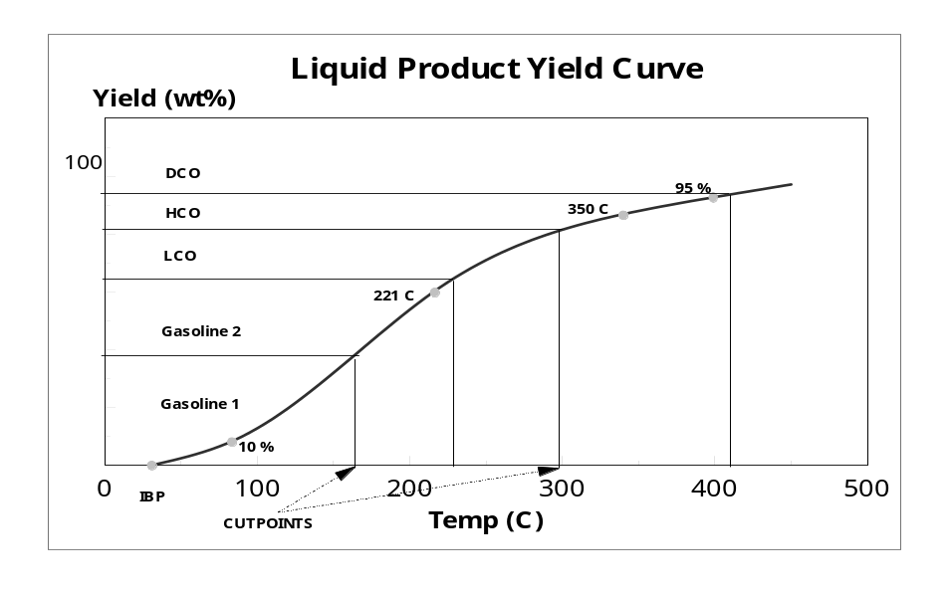
Figure 3.4_1 Total liquid product curve demonstrating the definition of cut point for perfect fractionation

In the predict case, the above process is reversed, and yields are read off the predict TLP curve at the user-defined cut points.

In imperfect fractionation, the recommended method, overlapping product distillations are generated through a shortcut fractionation algorithm based on Fenske equation and simplified thermodynamics for relative volatility of narrow fraction pseudo components. The separation of the TLP curve into the various products is determined by a series of binary separations, separating the liquid products in sequence from the heaviest to the lightest. Each binary separation is defined by 3 parameters: an effective cut point and 2 fractionation indices (FIs). The effective cut points have different definitions (and different values) but similar qualitative effect to the cut points used in perfect fractionation. The fractionation indices specify the fractionation efficiency between the various product streams, and can be thought of as proportional to the number of stages in the stripping and rectifying section of the binary separation.

In the base case, calculation of fractionation indices and cut points is carried out using the input liquid flows and distillations. An option exists to input fractionation indices in the calibrate case (see fixed format section of the unit monitoring spreadsheet). If there is any non-zero FI input in the calibrate case the model only computes cut points using the input FIs. Additional adjustment factors are computed so that all the points of the base distillation data can be matched by this distillation model.

In the predict case, the cut points and fractionation indices can be changed to model different separation of the reactor effluent, resulting in new predictions of liquid flows and distillations, which in turn lead to different quality predictions.

Starting from v3, the recommended option is imperfect fractionation. This is because previous robustness issues with this mode have been resolved and the calculation of stream distillation and properties is much more accurate using this mode. The only drawback is that the calibration in this mode is computationally more expensive. The execution time differences in predict mode (the mode used in optimization) are much smaller.

A new input in version 3 and later is a fractionation cut point between gas and combined gasoline. In addition to the fractionation algorithms described above, which fractionate pseudo components (narrow fractions) in the liquid range, an algorithm is used to fractionate light end (mostly c4 and c5, benzene in Catsim v3.1 and after) species amongst the combined gas streams and the different gasoline streams. In the base case this cut point is computed from gas/gasoline light end composition input and it can be changed in the predict case.

3.5 Feed Characterisation

A couple of feed qualities deserving discussion are C_{a} and percentage of hydrotreating.

C_{a} is the percent of aromatic carbon atoms in the feed. It has been shown to give predictions of coke and conversion that are significantly better than those obtained by using only the bulk feed properties. The feed characterisation technology based on nmr C_{a} has been shown to accurately simulate unit operation with drastic changes in feed (e.g., due to cat feed hydrotreating) which is not necessarily captured by the feed characterisation based solely on bulk properties.

Three different options are available to the user, and are set in the “Calculation options” section of the Unit Monitoring sheet:

- Option 0 (short): C_{a} is calculated from bulk properties (ABP and sg). The correlation used is derived from the pilot plant feed characterisation data. Note that the correlation has been updated for version 3. This mode allows users who do not measure C_{a} or refractive index to use the model.

- Option 1 (long): C_{a} is calculated using the n-d-m method. It is also derived from bulk properties (sg, ABP, Refractive Index, sulphur). It requires refractive index measurement, which is not needed for Option 0. Users should be careful when changing a single bulk property in the predict case (e.g. varying SG at constant RI) as it may lead to unreasonable computed C_{a}, resulting in poor coke and conversion predictions.

- Option 2 (input) C_{a} is measured directly by NMR (Nuclear Magnetic Resonance) analysis. The yield and product quality equations are based on this measurement. This is the most accurate method of feed characterisation. It represents an additional cost and analytical time delay if the analytical equipment is not available at the refinery.

The other feed quality requiring some explanation is what has been historically labelled as “Feed % Hydrotreatment” in the Catsim spreadsheets. It is NOT a fraction of hydrotreated material in the FCC feed but rather a weight percent of sulphur removed from the feed by hydrotreatment, representing a hydrotreater severity. So if a virgin feed with 2.0 wt% sulphur is hydrotreated and the resulting cat feed has 0.4 wt% sulphur, the “percentage hydrotreating” is 1.6/2.0*100=80.0 %. This quality is used to predict the sulphur distribution in the products and has no effects on heat balance or hydrocarbon yields.

3.6 Design Parameters

The weight hourly space velocity in an FCC is defined as the mass flow of feed divided by the mass of catalyst in the reaction zone. Defining the reaction zone is very much dependent on the unit design. For example, in a unit with closed cyclones, the required catalyst mass is in the riser only because the cracking reactions effectively stop in the cyclones. For a unit with an open cyclone system, the reaction continues in the dilute phase in the reactor and even in the overhead transfer line. Therefore, the mass of catalyst is the sum of that in the riser plus the dilute phase catalyst in the reactor and transfer line.

The calculation of WHSV in the base case is an iterative calculation. Most of the inputs required for this calculation come from the test run data and the base case heat balance. However, the following input data is also required:

- Dilute phase reactor catalyst hold-up - this is usually taken as the dispersed-phase catalyst mass in the volume between the final riser exit and the first-stage cyclone inlets. Contact your service engineer for help in estimating this quantity for your unit.
- Reactor cross sectional area - this is the cross sectional area of the reactor vessel (only really relevant if the reaction continues in the dilute phase in the reactor vessel).
- Riser volume - this is taken from the middle point of feed injection to the point of separation of the catalyst and reaction vapours e.g. with DCC s, the volume is calculated up to the centre line of the primary cyclone.
- Riser length - this is the total length of the riser.
- Riser vertical elevation - this is equal to the riser length if the riser is vertical. Otherwise, it is the vertical height of the riser.
- Standpipe inlet density and pressure- this is the inlet catalyst density and the pressure in the regenerated catalyst standpipe. This must be obtained from a pressure balance around the unit.
- Catalyst skeletal density - this is the density of the solid part of the FCC catalyst and does not account for any pore volume. This can normally be obtained from the catalyst manufacturer. If this is still not available, use 160lb/ft³ as an initial estimate.
- Riser slip factor - this is the ratio of the residence time of solid particles and vapour residence time in the riser. This is not so easily measured, and is normally determined from radioactive tracer tests. However, if this is not possible, assume the riser slip factor of two as an initial estimate.

Once these values have been entered into a specific unit’s model they will not need to be changed unless a revamp case is being studied.

In the predict case, the user can opt to calculate the WHSV using the base case coke and conversion. This makes the calculation quicker because it becomes a once-through calculation. The alternative method uses predict case coke and conversion, which requires WHSV as an input. This is slightly more accurate but it takes longer to run because it is iterative. This option is set in the Unit Monitoring “Calculation options” section.

3.7 Recycle

In CatSim, any of the cycle oil streams can be recycled. A blend of these streams can also be recycled. There are separate coke and conversion equations for the recycle feed and the fresh feed, which are then combined together to give the total coke and conversion. The recycle model is iterative until the cycle oil product qualities equal those of the recycled feed.

In order to predict the effect of recycle, it is not necessary to calibrate the model on a base case with recycle. As the recycle streams are being entered as feeds into the FCC process, they should have the standard quality data, e.g. distillation data and specific gravity, which are already predicted by CatSim. In addition, the streams should also be characterised for basic nitrogen and Conradson carbon, which are less likely to be analysed on a routine basis. If this data is not entered, CatSim will predict them. However, for a better accuracy, it is advised to select a base case which includes this data for simulating recycle operation.

There are two sets of base case unit factors generated for kinetic coke and kinetic conversion: one for fresh feed and one for recycle feed. Because there are two kinetic coke equations and two kinetic conversion equations, but only one value of coke make and one value of conversion in the calibration data, the errors in these two predictions are equally assigned to the fresh feed unit factors and recycle unit factors.

If the user has a good idea of what the average fresh feed kinetic coke and conversion unit factors are, these can be input into the “Unit Monitoring” sheet, thereby quantifying the error to be assigned to the fresh feed unit factors and vice versa. The remaining error will be assigned to the recycle stream, and hence the unit factors for kinetic coke and conversion will be different for fresh and recycle feed. This is only relevant for kinetic coke and kinetic conversion - the remaining yields are calculated using combined feed properties.

In the predict mode, with constant fractionation indices, for each recycle stream, there are three variables which are related: front-end cut point, recycle rate and product rate. Only two of the three are independent. Catsim is set up to input cut point and recycle rate and output product rate. Note that this way as you increase recycle at constant cut point you might end up with a non-physical negative product yield. Realistic simulation of recycle operation might involve changing both recycle rate and cut point to try and meet constraints on cycle oil qualities and minimum product flows.

3.8 Catalyst Management

For steady-state operation of an FCC, the E-cat metals level can be calculated from the feed metals level and the catalyst addition rate, by carrying out a simple metals balance. However, since the feed metals level to the FCC and the catalyst addition rate typically show some variation over time, at any one instant there will generally be a discrepancy between the metals levels coming in with the feed and the metals on the catalyst.

The metals level on the equilibrium catalyst is usually a reflection of the average feed metals over some period of time, rather than the feed metals level at any instant. It is the metals on the catalyst that affect the cracking process and for this reason the E-cat metals level is used, rather than the feed metals level, to calibrate the model. In the base case, the model calculates the effective feed metals level from the E-cat metals level and the catalyst addition rate. The user can think of this calculated metals level as the “average” feed metals level to the unit over the previous few weeks (depending on cat addition rate) from when the E-cat sample was taken. The catalyst addition rate entered by the user should also be an average addition rate rather than a spot addition rate. It is recommended that the user enters the average addition rate for the 10 days preceding the E-cat sample date.

The model uses the fresh catalyst and E-cat activity to calibrate the activity prediction equations. If fresh catalyst surface area is known but fresh catalyst MAT is not, the following relationship may be used as an estimation of the fresh MAT:

In the predict case, the user has the option of either entering a new feed metals level and allowing the model to calculate an equilibrated catalyst metals level, or keeping the E-cat metals level fixed (see Section 5.3)

The user should give careful consideration as to which option to use. CatSim is a steady-state prediction model. It is only capable of making predictions for changes that have reached a state of equilibrium. If a feed to the unit is only to be processed for a short period, the E-cat metals level will not have sufficient time to equilibrate to the new feed metals level. The model is not capable of calculating this non-steady state metals level and activity of the catalyst. For short-term feed processing (i.e. insufficient time for the E-cat metals level to equilibrate), it is recommended that predictions are carried out at constant E-cat metals, equal to the base case.

On the other hand, if the feed to the unit is to be processed for a period of weeks, then predictions should be carried out by inputting the feed metal levels and allowing CatSim to calculate the E-cat metals. This is also advisable for planning purposes, as it takes into account the difference in metals between the two feeds. When using this option, the user should always bear in mind that the predict case feed is not being compared with the base case feed, as the model is calibrated to the base case E-cat metals level and not the base feed metals level. Comparing two feeds should be carried out by running both feeds individually in predict case using feed metals as an input.

A second catalyst option exists in the predict case. The user has the choice of specifying the catalyst addition rate and allowing the model to calculate the corresponding E-cat activity or the user can target an E-cat activity and use the model to calculate the catalyst addition rate required to achieve that activity. Again, CatSim calculations assume that a steady-state condition has been achieved. The activity option only applies when the previous option is set to inputting feed metals.

3.9 Gasoline PIANO Representation

The existing Amoco PIANO representation was reviewed and updated based on the combined Sunbury and Naperville databases. It was further developed to enable the user to predict the effect of changing gasoline cut point on the gasoline composition. Starting from V4.0, the Gasoline PIANO by carbon number calculation has been merged into xlls. Therefore, the output pages of gasoline PIANO by C# are simplified into one sheet with the tab called “Gasoline Composition”. In this sheet, the PIANO by C# for both standard cut gasoline and plant gasoline streams are provided. However, the plant gasoline steam output depends on the input of plant gasoline composition for base case.

There are four analytical techniques available at the refinery, which can be used to determine gasoline compositions:

- FIA (Fluoro Infrared Analysis).
- PONA (Paraffins, Olefins, Naphthenes, and Aromatics). This is a GC method in wt%, which totals bulk molecular types.
- PIANO. A more detailed GC method than PONA, which separates components into the C5 to C11 carbon numbers paraffins, iso-paraffins, olefins, naphthenes and aromatics.
- PIONA. This is a more detailed version of PIANO, but the components are broken down further e.g. cis- and trans- versions of the same molecule.

The user selects which type of analysis is available to calibrate the model. If the user only has FIA or PONA to calibrate the model, only the PIANO by C# of stand cut gasoline can be predicted (with all the multipliers are assumed to be unity), plus the FIA or PONA. If the user inputs PIANO data, then a more accurate prediction of PIANO by C# of plant gasoline streams will be provided, plus the PIANO by C# for standard cut gasoline, as well as plant streams FIA and PONA.

The PIANO multipliers may be used to adjust the yields of individual species in the predict case.

3.10 Wet Gas Calculations

The wet gas calculation (identical in the base and predict case) is essentially a flash calculation of the predicted reactor effluent stream carried out at an input temperature and pressure (typically the low pressure separator condition). The results are the flow rate, composition and molecular weight of the wet gas stream. These quantities are useful to evaluate wet gas compressor constraints.

3.11 Iterative Calculation Loops in Catsim

CatSim contains some internal loops within the coding. Hence the model will normally run in an iterative mode. There is the option to run the model non-iteratively by switching some of the loops off when appropriate. The loops are listed below:

- Heat Balance - this enables the user to set the feed preheat temperature and calculate the catalyst circulation rate. The non-iterative mode has the catalyst circulation rate as input and the feed preheat temperature as output.

- WHSV - the calculation of WHSV in the predict case requires the predicted coke and conversion. These in turn require the WHSV, hence an iterative calculation is required to achieve convergence. If this loop is switched off, the base case conversion and coke values are used and the predict WHSV equals that of the base.

- Recycle - If the model is using recycle, the recycle representation is iterative by nature and it is then always running in an iterative mode.

- The regenerator temperature effect on catalyst deactivation rate - The coke make depends on the catalyst activity, whilst the equilibrium catalyst activity is affected by the regenerator temperature (defined in the predict case by the coke make) requiring an iterative calculation for the solution. This loop is effectively switched off if in the deactivation model regenerator temperature has no effect on deactivation rate (i.e. if k4 is set to zero).

4 FINDING YOUR WAY AROUND THE CATSIM SPREADSHEET

The CatSim spreadsheet contains a number of standard sheets which will be described in this section. The Unit Monitoring and Catsim worksheets introduced in section 2 are described in a little more detail, and additional standard utility sheets are introduced. CatSim can be customised to the individual refinery, so there may be some add-in sheets in a refinery’s particular model which will not be described here.

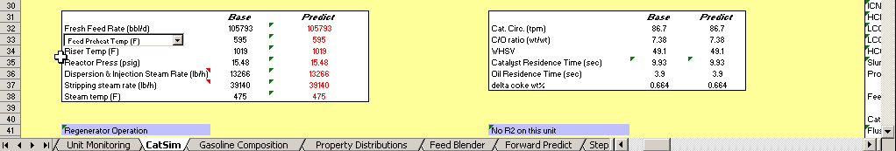

Figure4_1 Standard Catsim worksheets

4.1 Fixed Format and User Format

The most important worksheets described below are meant to be customised to fit specific user needs. To accommodate this, many of the worksheets have 2 sections: a “fixed format section” (one the left, typically hidden columns) and a “user format section” on the right, typically unhidden and where the user enters inputs/outputs.
The format (variables and the unit of measure) in the fixed format section is identical in all Catsim spreadsheets and should not be altered in any way by the user. This should be kept hidden for regular model use.

The main uses for this dual structure are to customise inputs and outputs to be shown in the refinery-specific units and translating measured quantities in the plant to actual model inputs. Examples of conversion or correlation which might be needed for data covering similar information is given here, where the actual model inputs are underlined.

- Conradson carbon and Ramsbottom carbon
- Specific gravity (sg) covers API gravity
- Basic nitrogen and total nitrogen

4.2 Unit Monitoring Sheet

This sheet is used to input test-run data (base cases) for processing in CatSim. It also serves as a storage or database for historical data, which can be quite easily trended or used for selection of a base case for a particular study. The data which needs to be inputted is a variety of feed quality, operating conditions, catalyst data and product data. This data can be pulled out from a refinery process information system, such as PI. Input and output sections are separated by a yellow row.

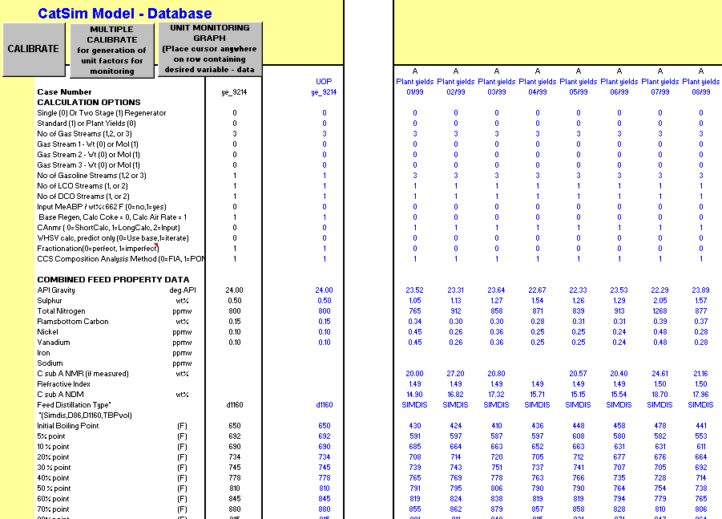

Figure 4.2_1 Unit monitoring sheet- top of input section

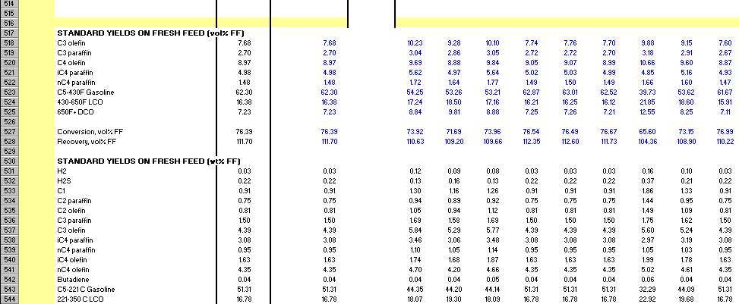

Figure4.2_2 Unit monitoring sheet- top of output section

The data input is split into various sections. The sections can differ from refinery to refinery depending on the unit design and operation, but are essentially as follows

- Calculation Options - the user must select certain options in the “Unit Monitoring” sheet. These are typically found in the top part of the sheet and are described in greater detail in Section 5.1. See Figure 4.2_1.
Following are the combination of (x,y) values which are input to the calibrate mode (see section 1.1)

- Combined Feed Property data.
- Reactor and Regenerator operation.
- Catalyst information - E-cat analyses.
- Hardware parameters - required for WHSV and residence time calculations.
- Gas component flows and data - gas stream GC data.
- Liquid product flows and data – gasoline streams and cycle oils.
- Standard Yield and quality inputs - required for standard yield mode only.
- Recycle operation data - flows of recycle streams and optional specification of unit factors.

This sheet will also contain the macro buttons for processing test-run or mini-test data and calibrating CatSim on a particular set of data. There is also a graphing function included in this sheet that can trend input data and outputs against time.

The bottom output section of the “Unit Monitoring” sheet (see Figure 4.2_2) is where some of the critical monitoring data generated from CatSim is output. This includes standard yields, standard yield unit factors, data quality check data, fractionation indices and plant product quality unit factors. This can be customised to suit the user.

Note: it may be necessary at some stage to expand the “Unit Monitoring” sheet to include new data inputs. The temptation is to select a complete row and insert a row. Both the “Unit Monitoring” and “CatSim” sheets have a “fixed format” section (see section 4.1) and inserting a row would alter this format causing problems to other tools interacting with the Catsim spreadsheet. Therefore, the recommended way to insert a new variable is to select the cells in a row after the active column, and insert cells. The fixed format should be kept write protected so that the user cannot inadvertently insert a row causing the problems described above.

4.3 CatSim Sheet

This is where most of the action occurs! Here, the user has the chance to carry out a prediction case by changing process variables, catalyst parameters etc. The layout is such that the user can see the base case data upon which the model is calibrated, and the prediction case next to it, thereby allowing easy viewing of the effects of changing variables.

In its un-customized user format, the “CatSim” sheet is split into 4 sections, which are adjacent to each other:

- Process and Yield data (columns K to U)
- Design and Optimisation (columns V to AD)
- Unit monitoring data (columns AF to AN)
- Plant data (columns AP to AX)

Each section can be accessed by manually paging across the “CatSim” sheet from left to right. One can also navigate different areas of the Catsim sheet through the CatSim menu in the Excel menu bar. The menu can be accessed by clicking with the left mouse button on the PMS menu or by pressing 'alt' & 'C'. Access to each area is achieved by clicking on that screen’s title in the CatSim menu. In the menu all of the items are navigation tools with exception of the first item (an information dialog box) and the last two items (which reset predict input values - see section 5.3).

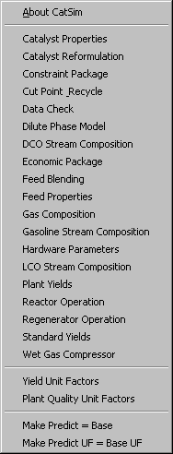

Figure 4.3_1 The Catsim Menu

Each section contains areas with related input data and results. Data displayed in red text are inputs and can be changed by the user. Data displayed in black text are calculated results and these cells are individually protected so that the user cannot inadvertently overwrite the contents.

Some important base case data is always visible at the top of each of these sections, as shown in Figure 4.3_2

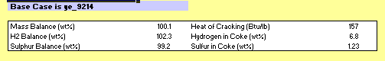

Figure 4.3_2

The following table indicates which data is available in each section.

Process and Yield Data | Design and Optimisation | Unit monitoring data | Plant data
Feed characteristics | Hardware parameters | Standard Yield unit factors | Gas component data
Reactor operation | Catalyst formulation | Plant Product Quality unit factors | Plant gasoline stream(s) data
Regenerator operation | Economics package | Standard Product Quality unit factors | Plant LCO stream(s) data
Fresh Catalyst Properties | Unit Constraints | Other monitoring data (heat of cracking UF) | Plant HCO stream(s) data
E-catalyst properties | Feed Blender
Flushing catalyst properties. | Wet Gas
Recycle streams
Main Frac and Gas Plant operation.
Standard yields
Plant yields

Further detailed description of areas where the user can input values and select options is given in the “how-to” section 5.

4.4 Gasoline Composition Sheet

This sheet contains the tabulated output of PIANO data and also FIA or PONA data for each plant gasoline stream and standard cut gasoline.

The display changes based on the user inputs:

If the user inputs FIA for gasoline composition in base case, only FIA and PIANO by C# of standard cut gasoline are displayed. If the user input PONA for gasoline composition in base case, only PONA and PIANO by C# of standard cut gasoline are displayed. If the user has PIANO by C# of plant gasoline streams inputted, then all the information including FIA, PONA, PIANO by C# of standard cut gasoline as well as plant gasoline streams will show up.

The multipliers input on this page have the similar meaning of unit factors. The final PIANO by C# are the result by multiplying the prediction result, the catalyst factors, the unit factors, and the multipliers. Therefore, if the user would like to change the unit factors from the base case, he or she should change the multipliers instead of changing the unit factors directly.

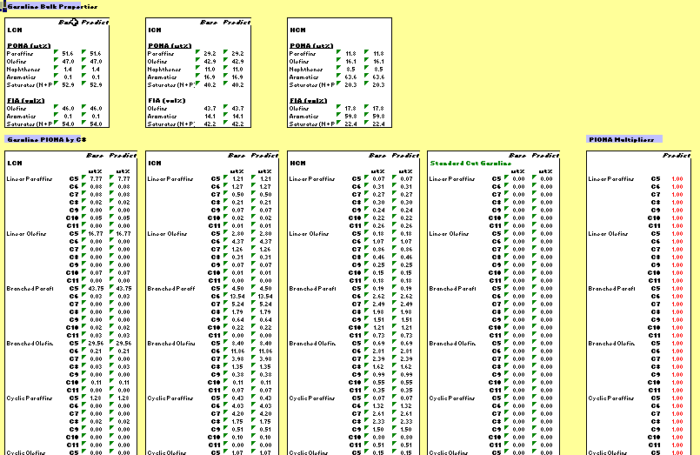

Figure 4.6_1 The Gasoline Composition sheet

4.5 Property Distributions Sheet

This is a tool which enables the user to look at the distribution of different properties with temperature in the form of a curve. The user must simply select one of the properties from the drop down box provided and shown in the figure below. This is a useful troubleshooting tool, as the predicted curves are adjusted in the calibration process to match input bulk stream properties. Poor calibration data (e.g. inconsistent sets of distillation and properties of liquid streams) can lead to non-physical-meaning values of these curves in certain boiling ranges.

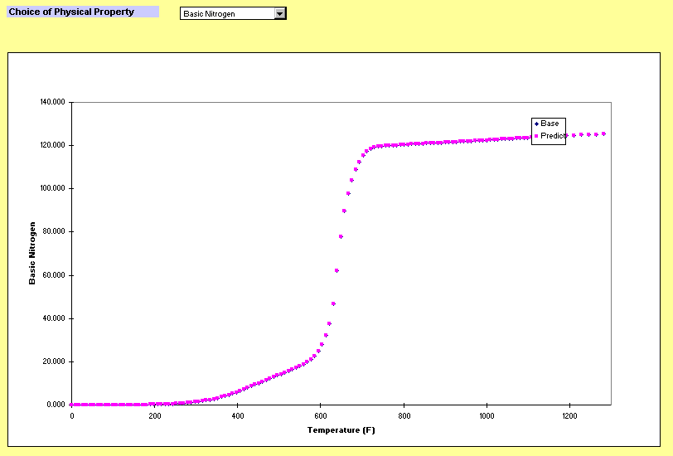Figure 4.5_1 The Property distribution sheet

4.6 Feed Blender Sheet

This tool allows the user to blend up to 10 different feeds together and it can be used to evaluate new feeds in the FCC. In order to do this the user must input distillation data, sg, conradson carbon, sulphur, basic nitrogen, nickel and vanadium into the Feed Blender sheet. By inserting the mass or volume flows of the different streams in the “CatSim” sheet’s Feed Blender section, the tool blends together the distillation data and other qualities. The blended data can be used as an input into a CatSim predicts case (see Section 5.6).

There is a reason for separating the Feed Blender input and output data between the “CatSim” sheet and the “Feed Blender” sheet. For optimising a case using the Excel Solver, all of the parameters to be adjusted (such as feed stream flow rates) must be contained within one worksheet. Starting with v3, some of the routines used by this sheet are contained in an external library, xldiscon.xll, which needs to be loaded for the Blender to work properly. See section 1.2.3 for details.

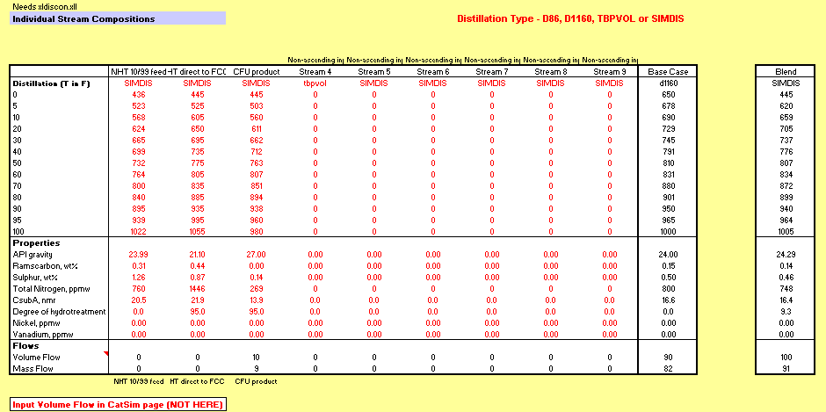

Figure 4.6_1 The Feed Blender sheet

4.7 Step Out Sheet

This is a tool which allows two different operating variables to be stepped and it creates a 3D plot showing how a third variable changes during these steps. For example, it can be used to create a visual representation of how operating profit changes with E-cat MAT and riser outlet temperature.

There is the option to run a specified Solver during each step, allowing optimisation within the pre-set Solver constraints. In order to be able to run this, the Solver add-in needs to be loaded.

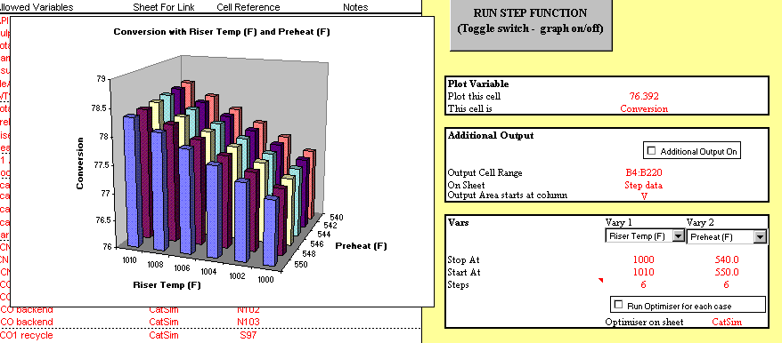

Figure 4.7_1 The Step Out sheet

Forward Predict sheet

This tool allows to carry out multiple predict cases in tabular form. To carry out the predictions, populate a few columns to the right of the button with valid inputs. One quick way to do this is copy the Base column values to the right and then modifies desired inputs. To run the cases, select a column and click the “Run Forward Cases”. The macro operates like the “multiple calibrate” macro (see section 5.1). The data starting at the selected column and ending at the first blank column to the right of the selected column will be run with output section at the bottom of the sheet being populated.

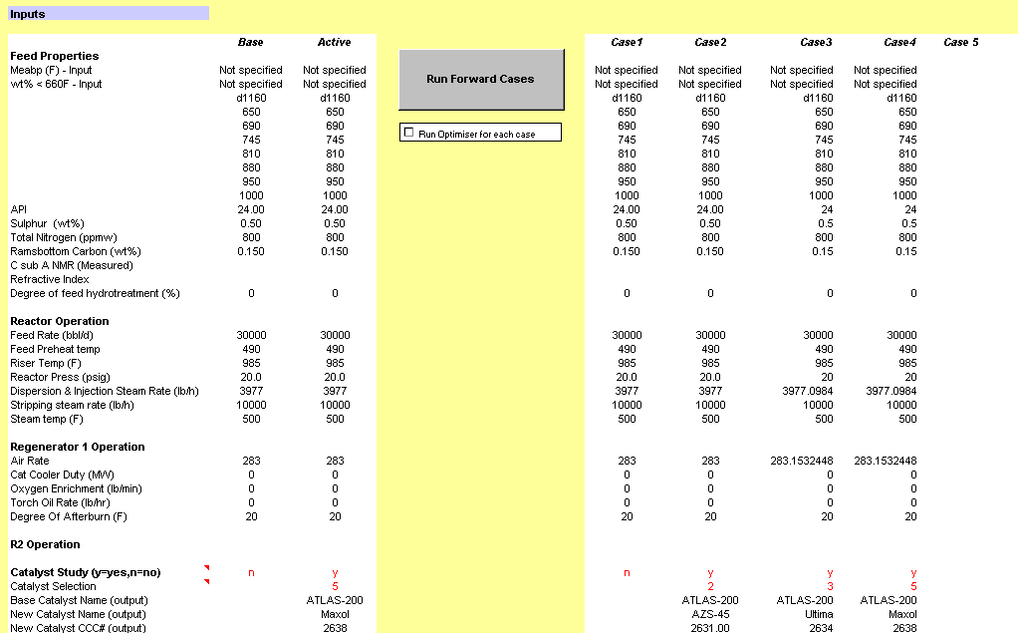

Figure 4.9_1 The Forward Predict sheet

5 HOW TO USE CATSIM/ CALCULATION OPTIONS

This section describes in more detail the how-to, such as “what buttons to press” and “how to do that” for a few of the sheets described in section 4. A detailed description of some of the inputs and, importantly, of the calculation options are contained here.

5.1 Processing Unit Test-Run Data

Once test-run or mini-test data has been inserted, the data can be very easily calibrated. If there is only one set of data to be calibrated, select any cell in that column of data (by putting the cursor on it to make it the active cell) and press the macro button labelled “CALIBRATE”. If there are two or more columns of data to be processed, select a cell in the column furthest to the left and press the macro button “MULTIPLE CALIBRATE”. All data sets starting from the selected column and ending at the first empty column to the right of the selected column will be processed in sequence by CatSim and the output generated will be copied into the lowest rows.

There are certain options found in the first few rows of “Unit Monitoring” sheet, which must be set for each data set. These will not normally change very often:

- Single- or two-stage regenerator. CatSim can simulate single- or two-stage regeneration. Two-stage here refers to regenerators with two separate flue gas streams. (This manual focuses on the single-stage regenerator option). The selected option is applied to both base and predict cases.

- The user has the option of entering the product yield and quality data on a standard cut basis, or on a raw plant yield basis. This option is chosen by entering a ‘0’ for raw plant data input or a ‘1’ for standard cut data in the appropriate cell. The minimum data input required for each mode is shown in the table below

Yield Option 0 Yield Option 1
(Plant Yields Mode) (Standard Yields Mode)
Feed Calibration Feed Calibration
RX/RGN Calibration RX/RGN Calibration
Catalyst Calibration Catalyst Information
Gas Stream Standard Yields
Gasoline Calibration
LCO Calibration
DCO Calibration

- Number of gas, gasoline, LCO, and DCO streams. These are limited to a maximum of three gas, three gasoline, two LCO, and two DCO streams. A minimum of 1 for each type (gas, gasoline, lco, dco) has to be entered. When entering the liquid streams, please remember that the fractionation model will sequentially split the liquid streams, so that the streams should be entered in order from lightest to heaviest. And that the distillation type input is needed for all seven liquid streams.

- Gas stream composition can be entered as molar or weight percent.

- Mean Average Boiling Point (MeABP) and wt% < 350ºC. The user can either input these values (choose option 1) or input the full distillation (option 0), in which case the model will calculate MeABP and wt%<350ºC.

- Base Regenerator heat balance - calculation of coke or air rate. If the user wishes to input flue gas analysis and air rate, then the coke make will be calculated. Conversely, the user may input flue gas analysis and coke make, such that the air rate is calculated. The option set here applies only to the calibrate case. The predict option case can be set independently in the Catsim sheet.

- Choice of C_{a} calculation in the feed characterisation - Option 0 uses a correlation to calculate C_{a} if only sg and distillation data are available; option 1 is the n-d-m method of calculating C_{a} if refractive index, sg and distillation data are available and option 2 is to input an actual C_{a} nmr value (See Section 3.8). The option set here applies to both calibrate and predict mode.

- WHSV calculation - option 0 for a non-iterative calculation (i.e. using the base case value) or option 1 for an iterative calculation with predicted coke and conversion (See Section 3.3).

- Fractionation option - perfect is 0 and imperfect is 1 (See Section 3.4). This applies to both base and predict mode.

- Gasoline composition analysis method - option 0 for FIA, option 1 for PONA and option 2 for PIONA (See Section 3.7).

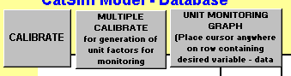

Figure 5.1_1 Macro buttons in Unit Monitoring sheet

5.2 Calibrating CatSim

Once a representative base case has been selected upon which to calibrate CatSim, the same method as above is used. In the “Unit Monitoring” sheet, select any cell in the column of data to be used and make it the active cell. Press the macro button “CALIBRATE”. This data should now be present in the Base case sections of the “CatSim” sheet, and this can be checked at the top of any of the CatSim screens. In the “Unit monitoring” sheet, the selected calibration case will be present in the “Active Column” The important factors to be considered in selecting a good and representative base case are detailed in Section 6.1.

5.3 Carrying Out a Prediction

A predict case is calculated in the “CatSim” sheet. Any value in red font can be changed by the user in the predict case. As already mentioned, values in red are input values and values in black are output or calculated values. The way this sheet has been set up is such that most of the user-manipulated data is in the first left-most screen. There are other data in the screens to the right, but these are likely to be less frequently changed. In the last screen, “Plant Data”, are all output data, i.e. they cannot be changed by the user.

Before starting a brand new predict case, it is good practise to ensure that “Predict = Base” and this is achieved by selecting the CatSim menu. Right at the bottom are two options:

- Make Predict = Base. This will set all of the user defined inputs (x) in the predict case equal to the base case values.
- Make Base UF = Predict UF. This will reset the unit factors which are exposed in the interface (and could have been changed in the predict case) to the base case values

Both of these options can take a few seconds depending on the speed of your computer, so please be patient!

Any of the following parameters enumerated in the following sections can be changed, and the user should be aware of the options available to them.

Process and Yield Data/ Predict options

In this screen, the following parameters can be varied: feed characteristics, reactor operation, regenerator operation, catalyst physical properties, main fractionator and gas plant operation, recycle stream and fractionation indices. This is also where all of the predict mode options are set. These are independent from the calibrate options which are typically set in the Unit Monitoring sheet.

Within feed qualities, the user can select to input complete distillation data and allow CatSim to calculate MeABP and Feed < 350°C. Alternatively, the user can select to input only MeABP and Feed < 350°C. One of these options can be chosen from the drop down box in the feed characteristics section shown in Figure 5.3.1_1

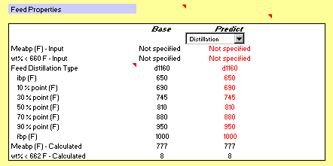

Figure 5.3.1_1 Feed properties option menu

Within the reactor operation section, the user can select either to carry out the predict case by inputting either the preheat temperature or catalyst circulation rate. The latter allows a once- through calculation to proceed. Again, a drop box is available to select the preferred option.

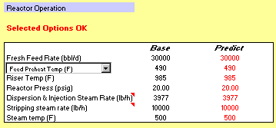

Figure 5.3.1_2 Reactor operation predict option menu

Within the regenerator operation section, the user has the option of either inputting a new air rate or calculating it. With the former option (input air rate), the user must simply input the required air rate (red value). In addition, if the unit is in partial burn, the user should ensure that the cell, “Min O₂ in flue gas (when in partial burn)” has a value entered, and that it is set to a realistic value. This O₂ level will be maintained in the predicted flue gas analysis. The predicted flue gas composition (black values in the middle box in Figure 5.3.1_3) will change while the red input values for target O₂ and CO₂ will be ignored. The second option (calculate air rate), is effectively a constant Orsat option. The user must input the red values for “Target O₂ in flue gas (constant Orsat option)” and/or “Target CO in flue gas (constant Orsat option)” depending on whether partial burn or full burn operation is required. The air rate calculated value (black, to the right in the top box in the figure) will change while the red input value will be ignored. The “Target Hydrogen in Coke wt%” is a required input for both options.
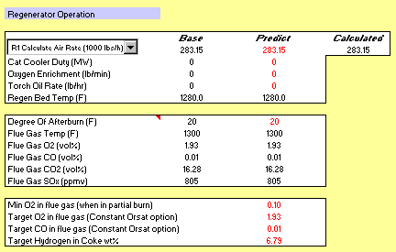

Figure 5.3.1_3 Regenerator operation predict option menu

The reactor and regenerator options described above can combine yielding 4 separate heat balance modes as described in the following table

 | Input  Catalyst circulation | Input Preheat Temp
Input  Air Rate | 1 | 2
Calculate  Air Rate | 3 | 4

All of the above modes are valid, but the ones labelled 1 and particularly 4 are recommended. Special caution has to be exercised when optimising using mode 2 as multiple solutions can arise and, as a parameter is varied, the model can exhibit discontinuous behaviour with the converged solution “jumping” from full burn to partial burn solution branches.

Within the catalyst physical properties section, the user has two different options:

- To input either fresh catalyst addition rate OR E-cat Activity (MAT).
- To input feed metals or E-cat metals.

Consideration on which option is best to use is described in section 3.6.

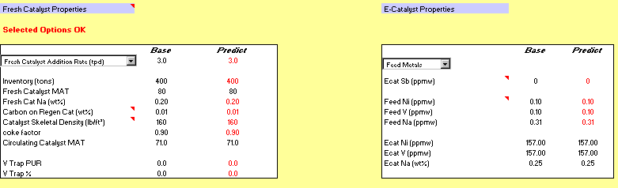

Figure 5.3.1_4 Catalyst management predict option menu

The changes in plant and standard yields and also changes in operating conditions can be viewed in this section. If any fractionation parameter (liquid backend cut points and fractionation indices, gas gasoline cut point) is changed, it is possible to quickly view the resulting changes in the plant products by clicking on the macro button at the top of the screen “Go to Plant Composition Data”. This will take the user to the “Plant Data” screen. To return to the cut point section, simply press on the macro button “Change Cutpoints”.

5.3.2 Design and Optimisation

The values of the following variables/parameters can be changed in this screen: hardware parameters, catalyst formulation, value of feed and products, unit constraints (this will only have an effect when optimising against constraints) and blending in new streams. These sections will typically need to be customized to match the refinery specific price structure. For feed blender inputs, the user must select whether to input blend flows in mass or volume units. In the wet gas section, the temperature and pressure of the low pressure separator can be changed.

5.3.3 Unit Monitoring Data

This screen allows the user to modify standard yield unit factors, plant and standard product quality unit factors. The usual situation for a predict case will be to let the predict unit factors equal those in the base case. However, if additional information is available on the effect of catalyst, hardware, or feed not properly captured by the model, the information can often be introduced in the model by modifying unit factors. Furthermore, the user could decide to use an average set of unit factors in the predict case.

5.3.4 Plant Streams

This last screen contains output information about the plant streams yield and fractionations. No inputs are present this section.

5.4 Using the Feed Blender

To use the Feed Blending tool the user must use two sheets - “CatSim” (Design and Optimisation screen) and “Feed Blender”. Starting off in “Feed Blender”, the user can enter qualities for up to 10 different streams, which can be anything from VGO to vacuum residue. The distillation type must be input (typed exactly) as SIMDIS, tbpvol, D86 or D1186. This is not case-sensitive. The only value that the user should not enter on this page is the flow rate of each stream.

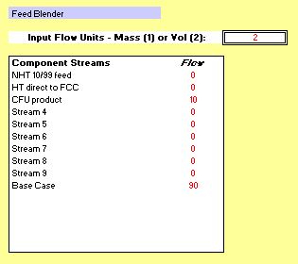

Figure 5.4_1 Feed Blender input on Catsim sheet

In the “CatSim” sheet, in Design and Optimisation, the user can input the flow rates of the various streams, with the option of entering the data either in mass or volume units (see Figure 5.4_1). These values are fed into the “Feed Blender” sheet, and the resulting qualities of the blended stream are fed back into the “CatSim” sheet.

If the user wishes to input the Feed Blender output into the predict case, he must click on the macro button in the “Process and Yield data” screen which says “Set predicted feed = blended feed”. This button is located on the right side of the Feed Properties section (see Figure 5.4_2). There is an additional macro button “Set predicted feed = base feed” should the user wish to return to the base case feed characteristics for the predict case.

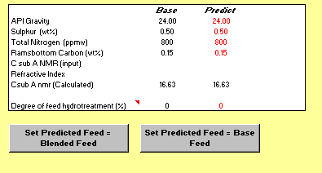

Figure 5.4_2 Buttons to activate (left) and deactivate (right) the Feed Blender

6 TROUBLESHOOTING

In this section one can find helpful information to troubleshoot common problems encountered in running Catsim.

6.1 Error Messages and Warnings

Starting from v3.1, the interface upgraded by UOP has a feature that will automatically check the compatibility of the interface and two xlls. If the interface find incompatibility of the interface and the engines, a message will be displayed when you first open the excel interface. When this happened, the user should check and fix the problem carefully before starting to run any case.

For the installation of CatSim on a fresh computer, a message will display in the CatSim sheet when the user start the Catsim before getting the license. The message indicates an “unauthorized user”. After getting the license, this message shall disappear. The license graded by UOP is typical working for one year. When the license is expired, license renew should be done before continuously using of Catsim. The renew process is identical to the first time authorization. The user should receive an automatically generated email from UOP, which remind the user to renew the license. The Catsim will keep idle until the licence is renewed. When the user see Catsim stop to response any input and command, he or she should check the license status using the license manager.

In both calibrate and predict mode, the calculation can fail due to missing or invalid input data, failed convergence of iterative loops or other reasons. When that happens, the model execution stops and returns an Error Message. Error messages different than the “OK” (which identifies a successful run) are displayed in the Catsim sheet, typically in cells M8 and N8 for calibrate and predict mode respectively. When an error appears in these cells, the outputs returned by the model are not a solution of Eq. (1) and should be ignored. The message is meant to help identify the reason for failure.

For some set input values, the model might complete the calculations successfully (returning “OK” as error message) but some model assumption or range of validity might be violated. When that happens, the model returns non-empty Warning Messages. These can be viewed under the error messages typically in cells Catsim!M9 and Catsim!N10 respectively for calibrate and predict. Unlike for error messages, when a warning message appears the output values are a solution to Eq(1), but the information conveyed by the warning message should be taken in to account when considering the validity of the solution.

6.2 Problems When Opening the Spreadsheet

When a Catsim spreadsheet is open, some message or error other than the ones described in section 2 might appear. This typically leads to incomplete initialisation and a non-working model. Here are known issues leading to this behaviour and tips on how to fix them.

- the “missing solver” problem. This manifests itself with a Visual Basic Editor message warning that it cannot find a library. The library which cannot be found is often the Excel Solver library. To verify this, after acknowledging the error messages, from Visual Basic Editor select Tools…References and check that the Solver entry is “missing”. The fix to this problem is to uncheck the Solver entry and re-add it manually by clicking Browse and navigating to select the file solver.xla.
After selecting the file, save the spreadsheet, close and reopen. The origin of the problem is typically a non-standard or incomplete Excel installation.

- the naming problem. Catsim spreadsheets names cannot contain spaces. To fix, just save the spreadsheet with a valid name (say substituting spaces with _, underscores), close it and reopen it.

- Xll location problem. This problem manifests itself with a message saying that xlls cannot be found. This could be caused by the model not being installed or being installed in a non-standard directory (or inconsistent with the particular spreadsheet). You can enter the correct directory path (containing the 2 xlls) after clicking OK at the previous message. You then need to save the spreadsheet, close it and reopen it.

6.3 Predict Is not Equal to Base

This happens where outputs in predict are not the same as in the base case (within model tolerances) when inputs are the same. This is an important way of checking model set-up and should be checked before doing any simulation.
One possibility is, of course, that the input values or the unit factors (which could have been modified in previous runs) are not actually the same in base and predict calculations. To make sure that is not the case, you might want to go to the Catsim menu, and select the options to “Make Predict = Base” and “Make predict UF = Base UF” (see section xxx)

Another possibility is that calibrate or predict modes crashed, and the inputs and outputs are hence not related by model technology in either mode. See section 6.1.

6.4 Metals/Activity Input Issues

Because the catalyst/metals model is a “long-term” steady state one, care must be taken in the input of catalyst activity and metals level. This is a common mistake which causes the model to crash or produce non-physical answers. In particular
- The equilibrium MAT can never have a value larger than the Fresh MAT.
- The Ecat metals levels can never be lower than the corresponding metal level on the fresh catalyst. This is often a problem in Na values, as they are typically non-zero in the fresh catalyst.

6.5 Excel Crashing.

The only known instance when the model causes Excel to crash and exit without possibility of recovery is related to the distillation type input. A common mistake is related to the fact that in the Unit monitoring worksheet, all seven liquid streams must have a valid distillation type input (d86,simdis,tbpvol,d1160). This is the case even if the stream is not present in that test-run/base case.

APPENDIX A MORE TECHNICAL ISSUES IN CATSIM

Important Note to the Catsim Users
The purpose of this appendix is to allow users to have a general understanding of the technology used in Catsim. However, the technology of Catsim is continuously being improved. As a result, the technical background presented here may not reflect the existing implementation of the technology in your version of Catsim. Therefore, inconsistency may occur when you try to verify the calculation in Catsim using the procedure in this appendix. If you happen to be in such a situation, consider the result produced by your Catsim as correct one.
A.1 Calculation Flow Diagrams

A.1.1 Calibration
Start Calibration
(input base case)

Calculate Regen
(Cat Circ Rate & Regen Temp UF)

Convert Gas Products
(Component rates and weight percents)

Total Liquid Products
(TLP curve)

Blend Recycle Streams
(Blended recycle properties)

Standard Yield Plant
(Std yield from plant yields input)
Convert Feed
(SIMDIST, meabp, feed<350, C:O, total feed properties)
Liquid Product Cut Points
(cutpoints TLP curve UF’s)
Fraction Indices
Std Liquid Product sg’s
(Std sg UFs)
Reactor Heat Balance
(reactor heat flow, cracking heat UF)
Yield Unit Factors
(Std yield unit factors)
Yield Unit Factors
(plant yield unit factors)
Plant Product Properties

Sulphur Balance
(flue gas SOx, S in Cake, S balance, S in Coke UFs)
Catalyst Management
(activity UF, catalyst deact const)
Hydrogen Balance
(H2 in feed, H2 balance)
End Calibration
Convert Liquid Products
(convert product dists to Simdist)

WHSV
A.1.2 Predict
Convert Gas Product
(base case data to wt%)

Convert Liquid Products
(base case liq product dist convertion)

Recycle
(blended recycle flow and quality)

Convert Feed
(MeABP, <350, C:O, total feed properties)

Catalyst Management
(activity, metals, Cat addition)
WHSV
Apply Yield Unit Factors
(actual Std yields)
Regen Calculation
(R1 temp, R2 temp, flue gas comp)
Catalyst Activity Converged ?

Plant Product Qualities 1

Sulphur Balance
(final liq prod and coke sulphur)
Recycle Converged ?

Plant Product Qualities

Reactort
(reactor heat flows, feed preheat temp, heat of cracking)
Hydrogen Balance
(H2 in feed, H2 balance)
Start Predict
(input predict case)

End Predict
Initialise Recycle Convergenece Values

WHSV Converged ?

Gas Products
(plant gas stream rates and composition, C4 in CCS, C5 in Gas)
Feed Preheat converged ?

A.2 Heat balance

A.2.1 Heat Balance

The heat balance consists of a reactor section heat balance and a regeneration section heat balance for both base and predict cases. The model is capable of simulating a single stage or a two stage regeneration section with the options of having a catalyst cooler, oxygen enrichment and torch oil combustion.

Taking the base case of single stage regeneration of as an example, either the amount of coke burnt in the regenerator or the air rate to the regenerator is calculated depending on what data the user inputs. If flue gas analysis and air rate are input, coke yield is calculated, if coke yield and flue gas analysis are input, air rate is calculated. Hydrogen in coke is calculated from the oxygen balance. The base catalyst circulation rate is calculated from the regenerator heat balance.

For reactor side, the base case reactor heat balance is closed using a heat of cracking unit factor and this unit factor is used for the reactor side heat balance of reactor side.

Things are more complicated for a two stage regenerator system especially for predict case. In predict case, the CO2/CO ratio is predicted as is the percentage coke burnt. To change from calculating coke burnt based on air rate to calculating air rate based on coke burnt would require the user to input the % coke burnt in R1. This is not a sensible user input, so for the R2R situation air rate is an input, and the air rate back calculation option available for a single stage regenerator is not available.

To solve the R2R heat balance in the predict case, the amount of coke burnt in the first regenerator must be predicted. The equations are based on E-cat Vanadium level which promotes the CO -> CO2 reaction, and have been generated using data from Kwinana and published literature.

Also, for two regenerator system, three conditions have to be considered when predicting the R1 flue gas prediction. They are the case when R1 is in partial burn and the case when R1 is in full burn and the transition between the two. As a result, the calculation procedures are different for these different conditions

A.2.2 WHSV Calculation

The WHSV calculation of base case and predict case are similar. For base case, calculation of WHSV requires the pressure at the bottom of the riser. Since this value is not an input to the model it needs to be calculated from a reactor pressure balance. The solution of the pressure balance is iterative and for this reason the base case WHSV is not a once through calculation. A calculation loop is required and indication of convergence of riser pressure drop. For predict case, the WHSV calculation requires coke make and conversion as inputs. For predict, however, predictive equations for both coke and conversion require WHSV, as a result it requires an iterative calculation. Because of this loop the model can be operated in two modes: with iteration “On” or “Off”.

If WHSV iteration is switched off then the calculation of WHSV uses the base case coke and conversion values, thus insuring predict will equal base. The benefit of switching this loop off is in maintaining a once through calculation procedure. However there is a small drop in model accuracy.

If the WHSV loop is switched on then the WHSV calculation uses the calculated values for conversion and coke make and an iterative loop is established that converges to these values.

A.2.3 Feed Preheat Calculation

To facilitate the model having a once through calculation, catalyst circulation rate is an input in the predict case. Hence the heat balance on the unit is closed using feed preheat temperature. In order to allow the user to input a feed preheat temperature, a solution procedure is required to find the correct catalyst circulation rate.

A Newton-Raphson type method is used to solve for the input feed preheat temperature. The procedure is repeated until the convergence tolerance is less than the input tolerance, or the input number of maximum iterations is reached:

Convergence tolerance = |(Calculated Preheat- Input Preheat)| / Input Preheat

The user should be aware that there are not enough degrees of freedom in the model for any value of feed preheat to be valid, thus a solution is not always possible (which is also the case on the commercial unit – not all feed preheats are obtainable).
A.3 Prediction of Standard Yield

The model gives the user the option of entering either raw plant data or standardised data. The model predicts the yields of all gas components from hydrogen to C4 as well as the three standard liquid cuts: C5 to 221Error: Reference source not foundC Gasoline, 221Error: Reference source not foundC to 350Error: Reference source not foundC LCO, and 350Error: Reference source not foundC+ DCO. The model can also predict C5s (in gas and in liquid).

A.3.1 Calculation of Standard Yields from Plant Data

If the user enters data on a raw plant basis, this must be converted to the standard yield form for calibration of the models yield equations. The procedure used to do this is as follows:

1. All liquid product distillations which are not entered on a Simdis (wt%) basis are converted according to the conversion methods detailed in Section 10. All of the Simdis (wt%) liquid product distillations are then blended into one total liquid product distillation.

2. The wt% of material boiling less than 221°C is calculated by linear interpolation of the total liquid product distillation.

- Procedure 2 is repeated for material boiling less than 350°C.

- If the individual analyses of the plant gas streams are input on a mol% basis, the model first converts these to wt%. The wt% of each component (C1, C2,.. ,C5+) in these streams is multiplied by the mass flow of each stream to give a weight of every gas component in each stream. The weight of components from hydrogen to C5+ in each stream is added up to obtain a total weight of these gaseous components.

5. The user enters the wt% of C4's in gasoline stream 1. The model assumes that the weight ratio of the C4's (iC4, nC4, C4=) in the gasoline stream is the same as the ratio in the C4 product stream. The weight of iC4, nC4 and C4= in the gasoline stream is added to the weight of these components in these gas streams.
6. The total weight of standard gasoline, C5-221°C, is calculated as:

weight C5-221°C = weight < 221°C (from 2) - wt C4 in CCS1 + weight C5 in gas streams
The wt% of the following standard products are calculated as the weight of that product divided by the total weight of all products.
Hydrogen (H2) Hydrogen Sulphide (H2S)
Methane (C1) IsoButylene(iC4=)
Ethane (C2+) Normal Butylene(nC4=)
Ethylene (C2=) Butadiene(C4==)
Propane (C3+) C5-221Error: Reference source not foundC Gasoline
Propylene (C3=) 221-350°C LCO
Isobutane (iC4+) 350+°C DCO
Normal Butane (nC4+) Coke

A.3.2 Standard Yield Prediction

The model uses the pilot plant based product yield equations (proprietary) as the basis for the prediction of standard yields.

A.3.3 Calculation of Yield Unit Factors

In the base case unit factors are generated for each one of the above standard yields by taking the ratio of the actual standard to the predicted standard yield (except coke yield).

Unit Factor = Actual Yield / Predicted Yield

In the predict case each yield prediction equation is multiplied by the corresponding unit factor (except the yields calculated by difference) to give predict case standard yield.

The coke yield unit factor is only applied to the catalytic coke part of the equation. In the base case the actual kinetic coke yield is assumed to be the difference between the actual coke yield and the predicted additive coke yield.

A.4 Fractionation and Prediction of Plant Yields

A.4.1 Construction of TLP curve

In the base case the first step is to construct a full product distillation curve by fitting a cubic spline to the combined liquid product. This curve is then deemed to be the base case total liquid product (TLP) distillation curve.

The TLP curve represents the combined distillations of all of the product streams and can be ‘cut up’ or fractionated into individual distillations; one for each of the liquid products. The model supports two methods for performing this fractionation - perfect and imperfect fractionation.

A.4.2 Perfect Fractionation

The cut point for each of the plant liquid products is determined by interpolating the temperature on the TLP curve at the cumulative mass flow of each product. The distillation curve for each product is simply the portion of the TLP curve between the streams front end and back end cut points.

This fractionation method means that there is no overlap between liquid products and thus non of the product distillations have tops and tails. These perfect distillations are used in all of the product quality narrow fraction summations. However, in order to match the input distillation curves a factor for each distillation point is used. This factoring is for user acceptance of the product distillations and in the predict case the displayed distillations will not always blend into the TLP curve.

A.4.3 Imperfect Fractionation

This option generates overlapping product distillations for use in product quality narrow fraction summations. This it simulates more accurately the effects of cut point changes and fractionation efficiency on these qualities.

The separation of the TLP curve into plant products is achieved by fractional distillation. How good the separation is depends on the number of plates in the column and the reflux ratio. For a given separation, it is possible to calculate how many plates would be necessary to perform the separation at total reflux. We call this number the Fractionation Index (FI). By assuming this FI is constant we can produce a simple shortcut distillation model.

The Fenske equation describes the distribution of component i relative to a reference component r, where the relative volatility α_{ir} is assumed constant:

y_{i} /x _{i} = α_{ir}^{N} * y_{r}/x_{r}

where: y, x are the mol fractions of components in the overheads and bottoms
N is the fractionation index (FI).

Within the model, two cut points are referred.

The yield cut point (YCP) is read from a plot of tbp wt% versus temperature of the feed to the separation. It is the temperature coinciding with the wt% yield of the two products. This is the cut point described in the perfect fractionation case.

The effective cut point (ECP) is the boiling point of the component, or an interpolation, which is present in equal amounts in the two products (i.e. the mid point of the narrow fraction that distributes evenly between the overhead product and the bottom product in the separation).

The model uses two FIs to describe a single separation. This is to handle the effect that the components lighter than the reference component are mainly in the upper (rectifying) section of the column and the heavier components in the lower (stripping) section, each section having its own FI. When calculating the distribution of narrow fractions, the changeover from the stripping FI to rectifying FI occurs at the effective cut point (ECP).

Given a feed stream described as weight amounts of standard narrow fractions (i.e. the TLP curve) a stripping and rectifying FI and an ECP, the distillation of the two products from the separation can be calculated.

The shortcut fractionation method described above allows us to generate a distillation for each of the plant product streams. For this a series of binary separations is performed starting from the TLP curve and first splitting out the DCO distillation, then the HCO distillation, and so on, until we are left with the distillation of the lightest gasoline stream.

A.4.4 Calculation of Fractionation Indices and Effective Cut Points

There are a number of ways to calculate values for FI’s. However, an FI can be regarded as a fitting factor that attempts to match a known product distillation. For this reason the method of calculation is secondary to the primary need to best match a known distillation.

A loop within a loop method is required to solve the base case fractionation calibration. This process will identify the FI’s that produce distillations that most accurately match the measured distillations and ECP’s that yield the correct plant liquid product flow rates.

A.4.5 Imperfect Fractionation Distillation Product Quality Calculation

For each product stream there is a measured value for the bulk quality. There is also a predicted quality distribution curve, assigning a quality of each distillation narrow fraction. A bulk quality value can be calculated from a narrow fraction summation of the product distillation curve and the quality distribution curve.

Due to the generic, non-unit specific approach to the prediction of a quality distribution curve this bulk value is normally different from the measured value. Thus the quality distribution curve needs to be tuned (proprietary) so that the predicted value is the same as the measured value.

A.4.6 Unit Factors

The definition of the unit factor for product quality:

UF =Actual - Predicted or UF = Actual / Predicted

A.4.7 Plant Yield Prediction

Very similar calculation procedure is used for predict case. The FIs and unit factor obtained in the base case are used to make up the final TLP from which any plant product cut can be calculated. With this TLP, a set of narrow fractions can be generated. Using these narrow fraction components and the short cut distillation method, any product stream can be produced.

A.5 Product Quality Prediction

The model is capable of predicting product qualities for standard liquid cuts as well as for liquid cuts of variable cut point. The user has the option of entering data on a standardised basis or on a raw plant yield basis. If the standardised product option is chosen, the product qualities entered by the user are used to calibrate a set of pilot plant based standard quality equations. These calibrated quality equations are then used for the forward predictions. If the raw plant data option is chosen, the model generates a set of product quality curves for each of the predicted qualities. These quality curves together with the total liquid product distillation curve are used to predict the various qualities of any liquid cut specified by the user.

A.5.1 Standard Product Quality Predictions

The model uses the pilot plant based product quality equations (proprietary) as the basis for the prediction of standard qualities.

In the predict case each standard quality prediction equation is adjusted by the corresponding base case unit factor (either by multiplication or addition as appropriate) to give predict case standard yield.

A.5.2 Plant Product Quality Predictions

To predict the quality of any specified liquid cut, the model uses a narrow fraction summation procedure together with the liquid product distillation curve and the relevant quality versus boiling point curve. Each quality curve, as well as the distillation curve, is divided into 10Error: Reference source not foundC narrow fractions between the cut point temperatures for each liquid product. The quality of each narrow fraction is estimated as the average of the interpolated qualities at the IBP and the FBP of the narrow fraction. Once the quality and wt% of each narrow fraction is estimated, the quality of the whole liquid product is calculated by linearly blending together all of the narrow fractions on a weight or volume basis as appropriate.

Qualities that blend linearly on a weight basis use the quality curve and the liquid distillation curve in the following narrow fraction summation routine to calculate the quality of the whole liquid product:

Qualities that blend on a volume basis require the liquid distillation curve to be on a vol% basis rather than a wt% basis. For these qualities the wt% distillation curve must first be converted to a vol% curve by using the SG curve. The narrow fractions can then be blended on a volume basis according to:

For qualities that do not blend linearly an appropriate blending index is used.

Each quality curve (as well as the distillation curve) is typically generated by fitting a cubic spline to several predicted points on the quality curve. If the liquid cut points are outside of the range for interpolation (i.e. they do not fall between the predicted points for the spline curves) then the splines are linearly extrapolated from the end points (extrapolation of cubic splines is generally not robust). The following sections detail how each quality curve is generated as well as the basis for blending of each quality.

The descriptions above hold for both perfect and imperfect fractionation. The difference is in how the distillation used in the narrow fraction summation is generated:

- For perfect fractionation the total liquid distillation curve (TLP) is used. The section of this curve between a products front and back end cut points is taken as the product distillation.
- For imperfect fractionation the products actual distillation as generated by the fractionation algorithm is used in the narrow fraction summation.

Please note that most product property predictions use above method. However, a few of them are calculated by bulk prediction equation or composition property equation, rather by the quality curve, for examples, the LCO cloud point, LCO pour point, LCO Cetane Index, Gasoline RVP, etc.

A.6 Product Recycle Prediction

Catsim allows any of the cycle oil streams, or any blend of these streams, to be recycled. The recycled streams are blended into one total recycle cycle oil stream and this is used as the recycle feed. This methodology may give a strange distillation if an unusual mix of streams is recycled and for this reason the user must be careful when deciding what to recycle (e.g. recycling a mix of 0.5 tonnes of LCO with 10 tonnes of DCO may be inadvisable)

The recycle model works by:

- Calculating kinetic coke and kinetic conversion for recycle and fresh feed.
- Combining these values to get the overall conversion and coke yield.
- Blending the flow rate and qualities of the recycled feed with the fresh feed, creating a total combined feed.
- Predicting the other yields and qualities based on total combined feed qualities, the calculated overall conversion and the subsequent model equations.
- De-blending recycled material from gross products to get net product yields.

This process is shown graphically below:

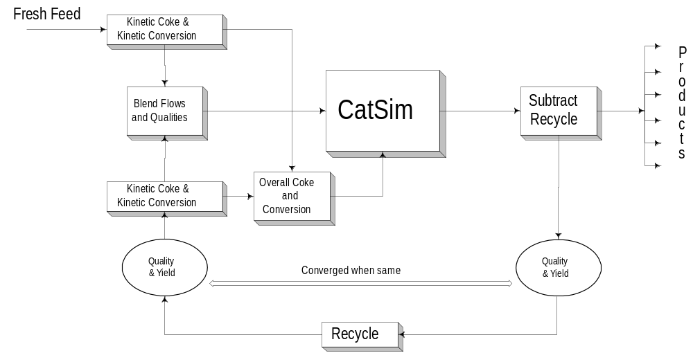

When material is recycled the yield and quality of the recycled material changes as the model goes through iteration. These iterations continue until the predicted yield and qualities of the recycled material are the same as those being blended with the fresh feed, at this point the model is said to be converged.

Within the XLLs direct substitution of the input qualities with the predicted qualities is used as the convergence method. At present the solver is used within Excel to solve situations where the user requires cut points to be changed to give specified recycle flow rates. An XLL solution method to allow this functionality could be developed as a future modification.

At present there are no internal checks on the material balance for recycle. This means that if the user attempts to recycle more products that he/she is producing the model will report a negative plant flow rate for that product.

A.6.2 Dual Calibration of the Recycle Model

When the model is calibrated on a single test run data set, a unit factor is calculated for the kinetic conversion and kinetic coke. Because the model has two equations for each of these predictions but only one set of calibration data the same unit factor is attributed to each of the equations.

This situation may not be ideal and by examining multiple test runs, with and without recycle, it may be possible to identify an average unit factor for the recycle or fresh feed equations. For this reason there are base case inputs available for kinetic conversion and kinetic coke unit factors.

Inputting a unit factor for the recycle kinetic coke or conversion will fix the error associated with the equations for the recycle material. Thus all of the error between the predicted and actual conversion/coke will be attributed to the fresh feed equations and a unit factor will be calculated.

Similarly if unit factors are entered for the fresh feed equations, values will be calculated for the recycle equations unit factors.

If both are entered, the recycle unit factors are ignored.
A.7 Catalyst Management Calculations

There are two calculation procedures in the catalyst management section of the model. The first is the metals calculation which relates to the E-cat metals level to the feed metals level and catalyst addition rate. The second calculation relates the E-cat metals level to the catalyst activity.

The relationship between feed metals and E-cat metals is given by a metals balance according to:

Feed Metals = (Ecat Metals - Fresh Cat Metals) * Catalyst Addition Rate / Feed Rate

Fresh catalyst metals (Ni, V, Fe and Na) are calculated off-line to take into account sodium on fresh catalyst and any nickel and vanadium on flushing catalyst.

The relationship between E-cat metals and activity is given by the following:

Where: E-cat KMat = E-cat MAT / (100 - E-cat MAT)
Fresh KMat = Fresh MAT / (100 - Fresh MAT)
VT% = Vanadium trap percent on inventory
RGT = Regenerator temperature (K)
Error: Reference source not found = Catalyst addition rate / inventory
k₁,k₂,k₃,k₄,k₅ = Constants tuned to a specific catalyst
Na = Sodium on E-cat (wt%)
V = Vanadium on E-cat (ppm)
UF = Unit factor generated from base case data

Fresh catalyst activity and total CAR are calculated off-line when flushing catalyst is in use.

The model can be used in two modes - with or without hydrothermal deactivation, depending on the k₄ value of the user-input deactivation constants. A default set of constants is provided in the fixed format of the ‘Catsim’ worksheet.

Using the above two equations, given any two of the following allows the other two to be calculated:

Feed Metals
E-cat Metals
Catalyst addition rate
E-cat activity and Fresh-cat activity

A.8 Material Balance and Element Balances

A.8.1 Material Balance

The base for material balance in Catsim is the inputs of base case. The Model calculates the material balance and its error from the fresh feed rate and the product rates. The user should be aware of the material balance of inputs if he or she sees significant error of material balance problem in Catsim.

A.8.2 Sulphur Balance

For base calculation, the model calculates a sulphur balance from the base case feed sulphur and product sulphurs (including flue gas SO_{x}) as:

Sulphur Balance % = Sulphur in Products / Sulphur in Feed * 100

If SO_{x} data is not entered by the user, the wt% sulphur in coke is estimated.

The wt% sulphur in DCO is calculated according to the pilot plant prediction equation. If flue gas SO_{x} data is entered by the user this is used to calculate the sulphur in coke. A unit factor for sulphur in coke is then generated as:

Sulphur in Coke UF = Actual wt% sulphur in coke/predicted wt% sulphur in coke

In the predict case, the sulphur content of the products are adjusted such that the predict case sulphur balance is the same as the base case:

Predict Sulphur in Coke (= wt% sulphur in DCO * UF (if applicable))

Calculate the sulphur balance.

Adjust the wt% sulphur in each product (including flue gas SO_{x} but excluding H₂S) proportionately such that the predict case, sulphur balance is the same as the base case. For example the new sulphur in gasoline would become:

New Sulphur in CCS = Predict Sulphur in CCS - (Predicted Sulphur in CCS /
(sulphur in products - H₂S) ) * Sulphur Balance error

The reason that H₂S is not adjusted results from the models calculation of CCS yield. CCS is calculated by difference in the model. If the H₂S yield were to be adjusted, this would affect the CCS yield, which would in turn affect the gasoline sulphur content, which would cause the sulphur balance to change and result in a complex iteration loop. Hence, to avoid iteration all product sulphurs except H₂S are adjusted to satisfy the sulphur balance.

A.8.3 Hydrogen Balance

As a check on the quality of the input data in the base case and of the predictions in the predict case, the model carries out a hydrogen balance for both the base and the predict cases.

The hydrogen content of the coke is calculated from a flue gas oxygen balance in the base case and is assumed to remain the same in the predict case. The hydrogen content of the gas streams are calculated directly from the molecular composition of each stream.

The hydrogen content of the feed and liquid product streams are predicted from the physical properties (SG and MeABP). An attempt is made to estimate the specific gravity of the limiting (maximum hydrogen content) paraffin and aromatic molecule at the MeABP of the stream. From the SG the carbon number (paraffins) and number of rings (aromatic) are estimated. The hydrogen contents of the paraffin and aromatic can then be calculated directly.

A.9 Distillation Conversion Methods

A.9.1 D1160 @ 10MM Hg to TBP Vol% @ 10 mm HG

The method used to convert from D1160 to TBP vol% at 10mm HG is based on the 1986 API method which is described in section 3A2.1 in the 1986 API data book. The method in the API book is a graphical method. The method calculates the temperature difference between each pair of D1160 points and then uses a graph to relate this to an equivalent TBP vol% difference. The curves work on temperature differences between the 0&10 % points , the 10 & 30 % points and the 30 & 50 % points. Temperatures at the 50 % point and above are estimated as the same for both distillation methods. The correction curve for 10-30% and 30-50% is the same , hence the result is two curves. The two correction curves have been estimated by polynomial expressions as taken from PPEFA. The two polynomials used are:

0 to 10 %:

DIFF OUT = (((-7.42308413E-7*DIFF IN + 2.22095232E-4)*DIFF IN - 2.88790713E-2)
*DIFF IN + 2.27019576) * DIFF IN - 7.4961674E-2

Where: DIFF OUT = temperature difference between the 0 % and 10 % TBP vol%
points.
DIFF IN = temperature difference between the 0 % and 10 % D1160 points

10 to 30 %:

DIFF OUT = (((-4.20211427E-7 * DIFF IN + 1.06765303E-4) * DIFF IN - 1.02138607E-2)
* DIFF IN + 1.36841183) * DIFF IN

Where: DIFF OUT = temperature difference between the 10 % and 30 % TBP vol%
points.
DIFF IN = temperature difference between the 10 % and 30 % D1160 points.

30 to 50 %:

Same equation used as for the 10 to 30% points.

The above equations are used directly to find the temperature differences between the 0 to 10% , the 10 - 30 % and the 30 - 50% points. If the required distillation points are in between these points, then the D1160 temperature differences are scaled up so that these equations can be used , and then the resulting TBP vol% differences are scaled back down again in the same proportion. So far example, if the first two points in the D1160 distillation were a 0% point and a 5% point , the temperature difference between these points would be doubled so that the 0 - 10% correction equation could be used. The resulting 0 - 10% TBP vol% temperature difference would then be halved to get the 0 - 5% TBP vol% difference.

A.9.2 TBP vol% @ 10mm Hg to D1160 @ 10mm Hg

This procedure is identical to procedure 10.1 except that the two temperature difference correction polynomials are as follows:

0 to 10%:

DIFF IN = (DIFF IN - 40) / 20
DIFF OUT= (((0.2314814775 * DIFF IN + 1.064814815) * DIFF IN + 3.24074076)
*DIFF IN + 15.7407411) * DIFF IN + 23.333333

10 to 30% and 30 to 50%:

DIFF IN = (DIFF IN - 50) / 25
DIFF OUT = (((0.13888888 * DIFF IN - 0.3240741) * DIFF IN + 0.2777777)
* DIFF IN+ 26.2962963) * DIFF IN + 46.666666

TBP vol% to d86 vol%

This conversion method is based on the paper by TE Daubert in Hydrocarbon Processing, September 1994. The method first calculates the D86 50 % point directly from the TBP vol% 50 % point. There are then a set of correlations to calculate the D86 temperature differences away from the 50% point for the 0%, 10%, 30%, 70%, 90% and 100%. These are a function of the equivalent TBP vol% temperature differences away from the 50 % point. The 50 % point is calculated as follows:

D86 50 % = 1.1431 * TBP 50% ^ 0.97485

Temperature points below the 50 % point are calculated by subtracting a temperature difference from the 50 % point according to the following :

D86 % point (i) = D86 % point (i +1) - E * (TBP(i+1) - TBP(i)) ^ P

Temperature points above the 50 % point are calculated by adding a temperature difference from the 50 % point according to the following:

D86 % point (i+1) = D86 % point (i) + E * (TBP (i+1) - TBP (i)) ^ P

Where the values of E and P are as follows:

RANGE | E | P
0 - 10 | 0.03606 | 1.6599
10 - 30 | 0.10879 | 1.3958
30 - 50 | 0.25043 | 1.2488
50 - 70 | 0.32268 | 1.2195
70 - 90 | 0.22911 | 1.3246
90 - 100 | 3.622 | 0.60219

Example:

D86 30 % point = D86 50 % point - 0.25043 * (TBP 50% - TBP 30%) ^ 1.2488

Each actual range may not be the same range as the range of the correlation i.e. we may wish to convert points other than just the 0, 10, 30, 50, 70, 90 and 100% points. If the range between two distillation points is greater than a correlation range then it is necessary to work out the contribution from each correlation to the total difference of the range.

Example. If we had a 10 % point and the next point we had was the 50 % point, then the contribution from the 10-30% correlation would need to be worked out and added to the contribution from the 30-50% correlation to get the total temperature difference. Similarly , if a required range was less than a correlation range ,i.e. a 0% and a 5 % point then the temperature difference would only be the proportion of the correlation range.

A.9.3 D86 vol% to TBP vol%

This conversion method is identical to the method in 10.3 except with different values for the constants. The 50 % conversion equation is as follows:

TBP 50 % = 0.8718 * D86 50% ^ 1.0258

The values for E and P are as follows:

RANGE | E | P
0 - 10 | 7.4012 | 0.60244
10 - 30 | 4.9004 | 0.71644
30 - 50 | 3.0305 | 0.80076
50 - 70 | 2.5282 | 0.82002
70 - 90 | 3.0419 | 0.75497
90 - 100 | 0.11798 | 1.6606

A.9.4 Simdis wt% (D2887) to D86 vol%

This conversion method is identical to the method in 10.3 except with different values for the constants. The 50 % conversion equation is as follows:

D86 50 % = 0.77601 * SD 50% ^ 1.0395

The values for E and P are as follows:

RANGE | E | P
0 - 10 | 0.3047 | 1.1259
10 - 30 | 0.06069 | 1.5176
30 - 50 | 0.07978 | 1.5386
50 - 70 | 0.14862 | 1.4287
70 - 90 | 0.30785 | 1.2341
90 - 100 | 2.6029 | 0.65962

A.9.5 D86 vol% to Simdis wt% (D2887)

This conversion method is identical to the method in 10.3 except with different values for the constants. The 50 % conversion equation is as follows:

SD 50 % = 1.2763 * D86 50% ^ 0.962

The values for E and P are as follows:

RANGE | E | P
0 - 10 | 2.8735 | 0.88818
10 - 30 | 6.33646 | 0.65893
30 - 50 | 5.17255 | 0.64994
50 - 70 | 3.79746 | 0.69994
70 - 90 | 2.59778 | 0.81031
90 - 100 | 0.23451 | 1.51602

A.9.6 Simdis wt% (D2887) to TBP vol%

This conversion method is identical to the method in 10.3 except with different values for the constants. The 50 % conversion equation is as follows:

TBP 50 % = 1.000 * SD 50% ^ 1.000

The values for E and P are as follows:

RANGE | E | P
0 - 5 | 0.15779 | 1.4296
5 - 10 | 0.15779 | 1.4296
10 - 30 | 0.011903 | 2.0253
30 - 50 | 0.05342 | 1.6988
50 - 70 | 0.19861 | 1.3975
70 - 90 | 0.31531 | 1.2938
90 - 95 | 0.97476 | 0.8723
95 - 100 | 0.02172 | 1.9733
A.9.7 TBP vol% to Simdis wt% (D2887)

This conversion method is identical to the method in 10.3 except with different values for the constants. The 50 % conversion equation is as follows:

SD 50 % = 1.000 * TBP 50% ^ 1.000

The values for E and P are as follows:

RANGE | E | P
0 - 5 | 3.63865 | 0.6995
5 - 10 | 3.63865 | 0.6995
10 - 30 | 8.91564 | 0.49375
30 - 50 | 5.60968 | 0.58865
50 - 70 | 3.17925 | 0.71556
70 - 90 | 2.44025 | 0.77292
90 - 95 | 1.02974 | 1.14639
95 - 100 | 6.96341 | 0.50677

A.9.8 Boiling Point Pressure Conversion

To convert a distillation temperature from one pressure to another API procedure 5A1.13 is used assuming that the Watson K of the fraction is equal to 12. Procedure 5A1.13 can be used to calculate the vapour pressure of a hydrocarbon at any temperature given the true boiling point of the hydrocarbon. Hence, if the distillation temperature at 760 mm Hg is known, then the distillation temperature at any other pressure can be calculated. The method can be used in reverse to calculate the distillation temperature at 760 mm Hg given the distillation temperature at any pressure. If the distillation temperature needs to be converted from one pressure to another, neither of which are 760 mm Hg, the temperature at 760 mm Hg must first be calculated and then converted to the desired pressure. There are three equations used for different vapour pressure ranges:

Where:

A.9.9 D1160 @ 760 mm Hg to D86 & Simdis

In accordance with the API methods for distillation conversion, there is no direct method of converting from D1160 to D86 or Simdis. Instead, a number of separate conversions have to be made. The conversion path is as follows:

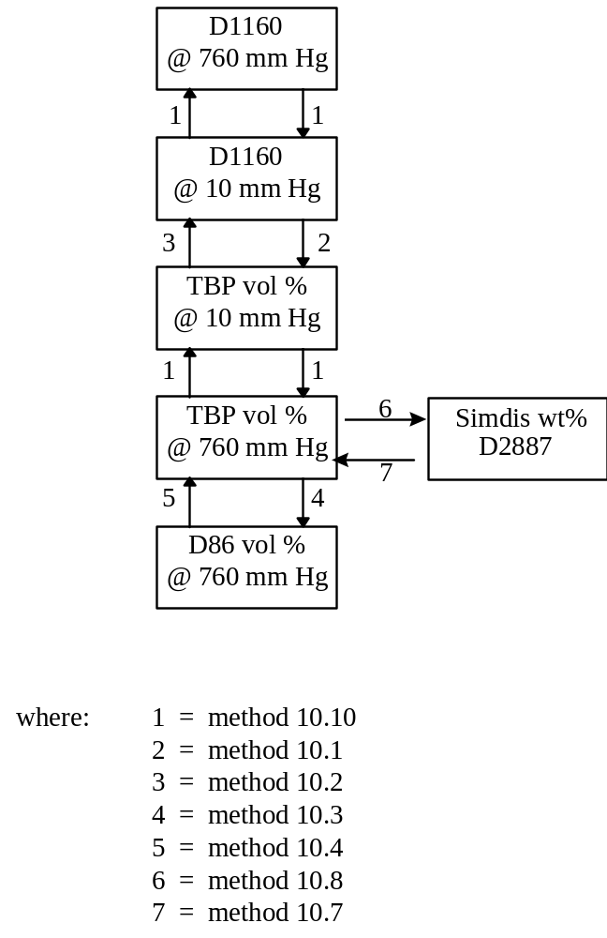
A.10 Physical Property Calculations and Conversions

All distillation conversion methods have been taken from the 1987 API data book.

The general method is to convert the distillation type to equivalent D86 values, this allows determination of VABP (Volume Average Boiling Point). From the methods given in the data book, delta's can be evaluated to convert VABP to WABP (Weight), MABP (Mole), MeABP (Mean), and CABP (Cubic Average Boiling Point). All temperatures are in degrees Rankine.

A.10.1 Generation of Characterising Boiling Points

Given the D86 10%, 30%, 50%, 70%, and 90% points the VABP can be determined:

VABP = T10 + T30 + T50 + T70 + T90
5

Deltas can then be evaluated by the following equations to allow determination of the various characterising boiling points:

WABP = VABP + Del 1
MABP = VABP - Del 2
CABP = VABP - Del 3
MeABP = VABP - Del 4

ln (Del 1) = - 3.062123 - 0.018929 (Tv - 32) 0.6667 + 4.45818 SL 0.25

ln (Del 2) = - 0.56379 - 0.007981 (Tv - 32) 0.6667 + 3.04729 SL 0.333

ln ( Del 3) = - 0.23589 - 0.06906 (Tv - 32) 0.45 + 1.8858 SL 0.45

ln (Del 4) = - 0.94402 - 0.00865 (Tv - 32) 0.6667 + 2.99791 SL 0.333

WABP MABP CABP MeABP and VABP in oF.

Tv = VABP
SL = (T90 - T10) / 80

(API Data book 1987 Sect 2-11)

A.10.2 Conversion Between MAT and RMA

The following correlations have been derived from Naperville data:

MAT = 100 * (0.6 + 0.884 * (0.01 * RMA) ^ 2) / (1 + (0.6 + 0.884 * (0.01 * RMA) ^ 2))

RMA = 100 * SQRT (((G153 / (100 - G153)) - 0.6) / 0.884)

A.10.3 Conversion Between Conradson Carbon and Ramsbottom Carbon

Re-correlation of the ASTM data on Ramsbottom carbon vs. Conradson carbon, making sure that equations are analytically reversible and always positive, led to the following equations:
For ConC<0.01 or RamsC<0.0553
RamsC = 5.53*ConC
For higher values (works great up to 20wt% of either one):
RamsC = EXP(0.0666*ln(ConC)^2+0.8821* ln(ConC)-0.2448)
And the reverse transformation:
ConC=EXP((-.8821+SQRT(0.8821^2+4*0.0666*(0.2448+LN(RamsC))))/(2*0.0666))

A.10.4 Conversion Between Meabp, Vabp and ABP

The following correlations have been derived from Sunbury data:

freshfeed_abp = (DEGC_TO_DEGF * (freshfeed_meabp) + 11.268) / 0.9672
freshfeed_vabp = (DEGC_TO_DEGF * (freshfeed_meabp) + 1.8283) / 0.9855

Appendix B MODEL RESPONSE TO KEY PARAMTER CHANGING

Important Note to the Catsiml Users
The purpose of this appendix is to allow users to have a general understanding of the performance of Catsim. Those charts presented here should neither be seen as the real application cases nor be served as any bench mark or guild line. The technology of Catsim is continuously being improved. As a result, those charts may not display the same responses of your version of Catsim. Therefore, inconsistency may occur when you try to compare the result of your Catsim with the result presented here. If you happen to be in such a situation, consider the result produced by your Catsim as correct one.

B.1 Charts of Step Changes

The charts starting from next page show some typical responses of Catsim when some key operating parameters or feed parameters change. The calculation were done in such a way that move the test parameter step change but keep all other input conditions with the same values.
